

Design Strategy Document (DSD)

Client: Audi
Course Name: The A3 Model family
Course Length: 45 minutes
Learning Objectives:
- Describe the design and performance features of the 2024 Audi A3, S3, and RS 3.
- List the technology and driver assistance features of the 2024 Audi A3, S3, and RS 3.
- Explain the driver assistance features of the 2024 Audi A3, S3, and RS 3.
- Create customer benefits statements tailored to the customer demographics of the 2024 Audi A3, S3, and RS 3.

Details: This content outline is intended to direct the development of a 45-minute interactive PPT.

Welcome (top nav item)
Slide | Content
While You Wait . . . | Standard text  
Learning Objectives | - Describe the design and performance features of the 2024 Audi A3, S3, and RS 3.  - List the technology and driver assistance features of the 2024 Audi A3, S3, and RS 3.  - Explain the driver assistance features of the 2024 Audi A3, S3, and RS 3.  - Create customer benefits statements tailored to the customer demographics of the 2024 Audi A3, S3, and RS 3.
Agenda | Welcome  Design  Performance  Technology  Driver Assistance  Demographics and Owner Experience  Exit Ticket
Group Discussion | Standard text
Housekeeping | Standard text
Introducing the A3 model family | Here are the models in the A3 family.  - 2024 A3  With the Audi A3, you get the premium features and functionality of a full-size sedan—in a size built for your life.  - Sportback – Internal Combustion Engine (ICE) or Diesel  - Sedan – ICE or Diesel  - Allstreet - ICE or Diesel  - 2024 S3  The S3 is a compelling high-performance entry to the Audi S-portfolio:  - Sportback – ICE  - Sedan – ICE  - 2024 RS 3  The RS 3 combines unmatched sportiness and suitability for everyday use:  - Sportback – ICE  - Sedan – ICE
 | 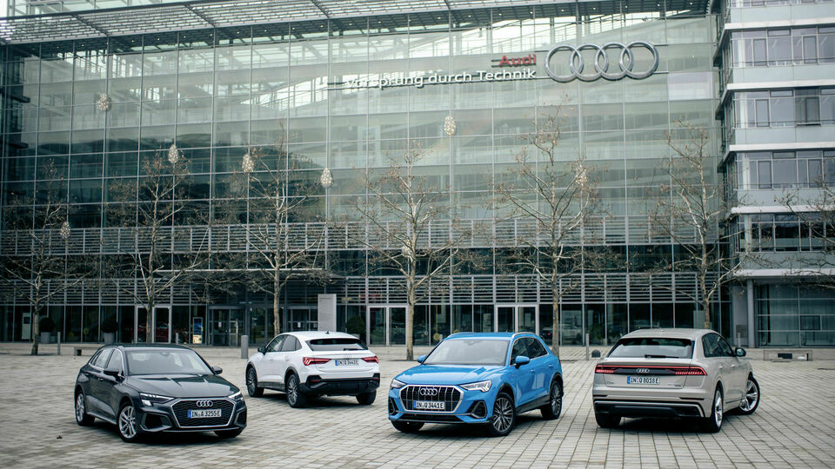
 | 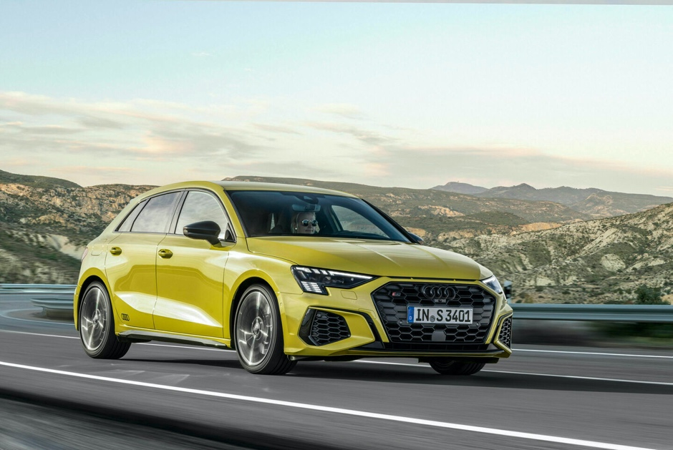S3 sportback
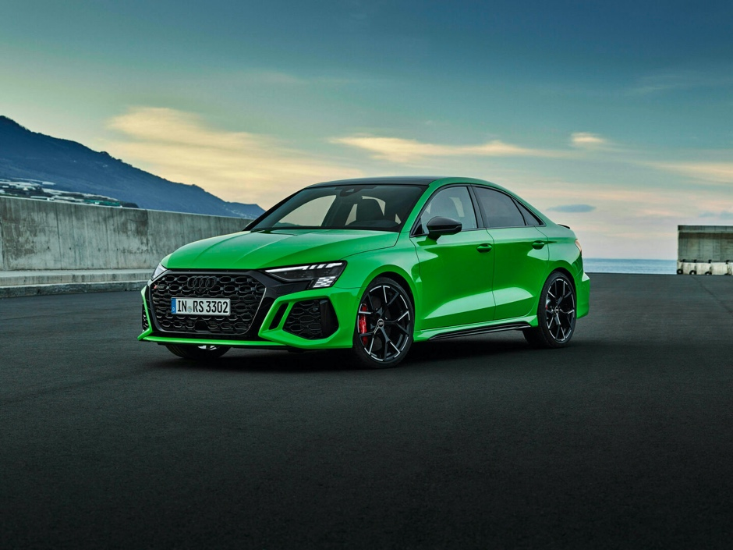
RS Sedan

Design (top nav item)
Slide | Content
Interior Upgrades | All A3 models have these interior upgrades:  - New style compact gear selector  - Available driver seat memory  - Interior storage package with USB-C ports  Customer benefit: The interior features a revised layout and enhanced technology that puts driving information at the customer’s fingertips.
 | 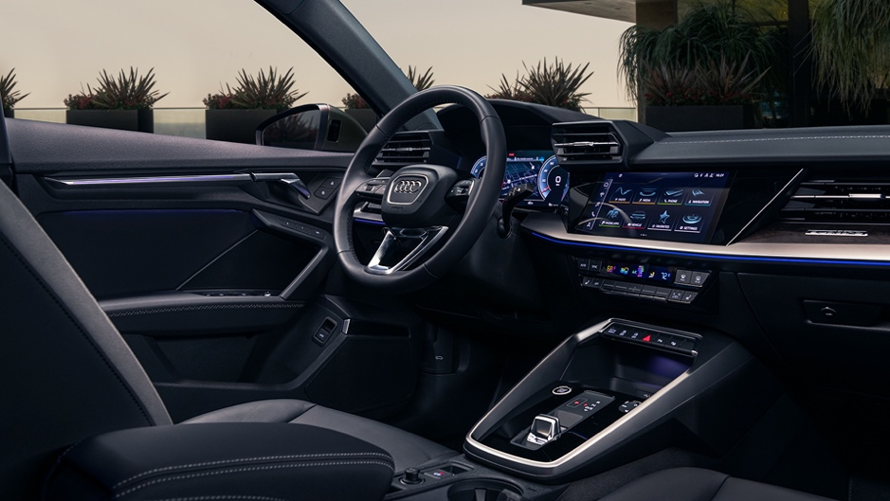
Seat Memory Function | Video: Seat Memory Function  Question: How does seat memory enhance the driving experience?
 | 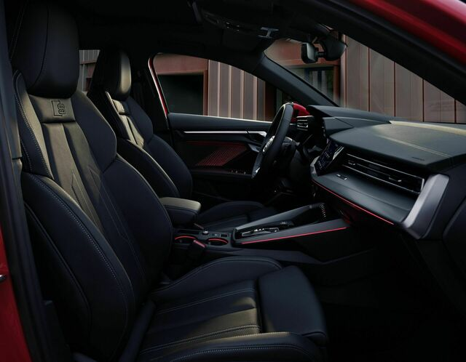
A3 Exterior Design | The new A3 is longer, wider, and taller than its predecessor. Some of its exterior design features are:  - Aggressive hood sculpting  - Bold Singleframe® grille with honeycomb design  - Aerodynamics enhanced by fully paneled underbody and improved exterior mirror design  - Full LED headlights with DRL signature
 | 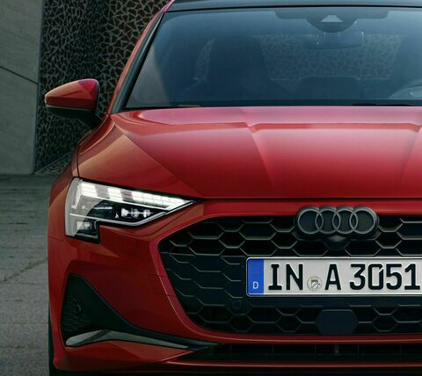
More about A3 Exterior Design | Video: Audi A3 Exterior
S3 Exterior Design | Exterior design features include the same features as the A3, plus:  - Redesigned honeycomb Singleframe® grille. Comes with available black exterior mirror housings (aluminum optic standard)  - Standard 18” wheels with available 19” wheels
 | 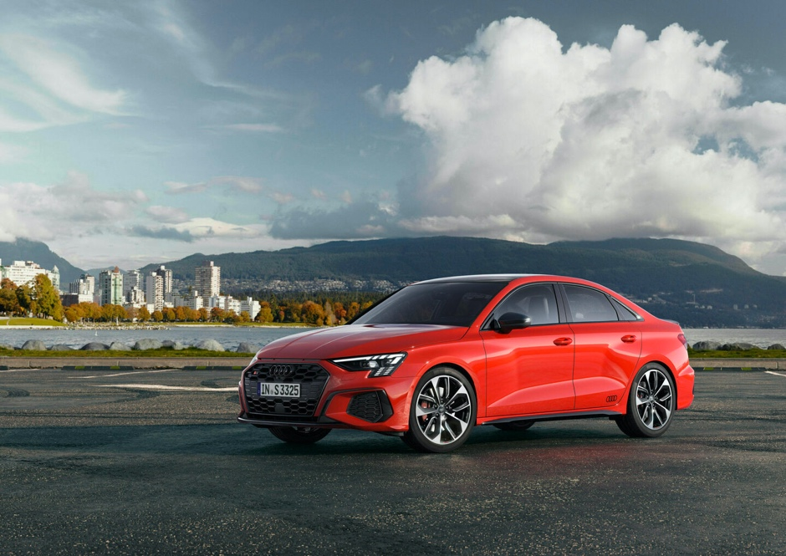
RS3 Exterior Design | Exterior design features include:  - Flared wheel arches - tread widened by 1.3in on the front track  - Larger singleframe grille with new honeycomb structure  - RS 3-specific daytime running lights (DRLs) with checkered flag animation  - Matrix-design LED headlights
 | 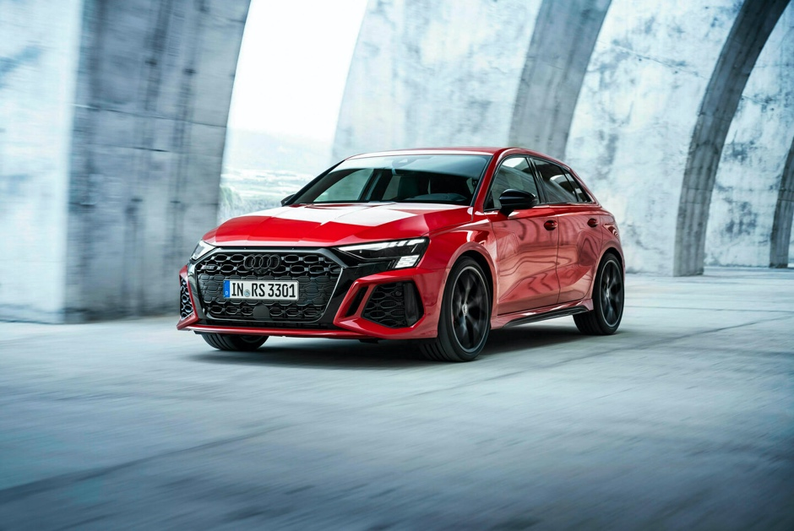
A3 Interior Design | Some of its interior design features are:  - Available Agate gray fine grain birch wood inlay and standard Platinum gray inlay  - Seats with standard contrast stitching in black, brown, or beige
S3 Interior Design | Some of its interior design features include:  - Perforated steering wheel with S logo  - Available Carbon atlas structure inlay and standard Aluminum spectrum  - Sport seats in black with gray or red stitching or Sport seats in gray with gray stitching
 | 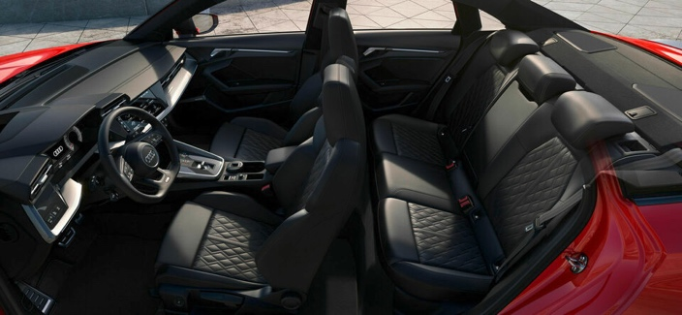
RS 3 Interior Design | Some of its interior design features include:  - Perforated steering wheel with S logo  - Available carbon atlas structure inlay and standard Aluminum spectrum  - Sport seats in black with gray or red stitching or Sport seats in gray with gray stitching
 | 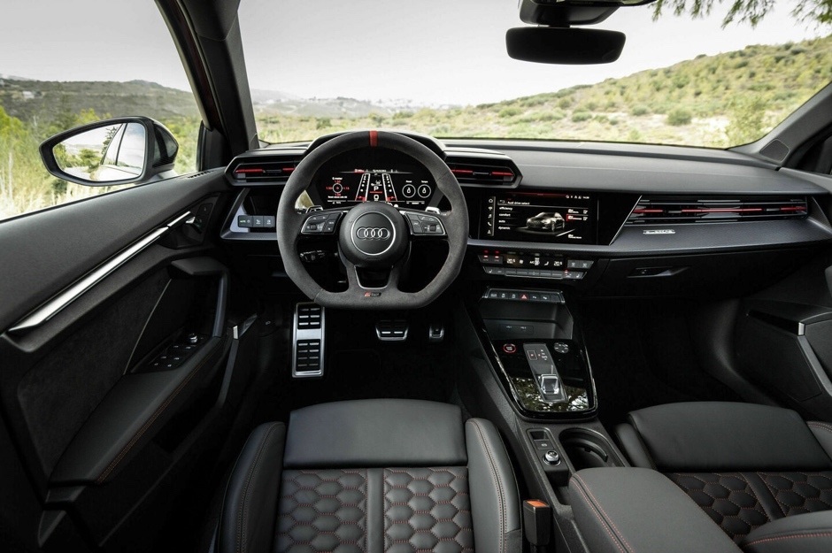
Activity – Which is the Best?
The purpose of this activity is to help participants think through which design features might appeal most to customers.
- Ask participants, “What is your favorite design feature among the ones we’ve covered?”
- Record answers on a flip chart or whiteboard. (Don’t record repeats.)
- Now set a timer for 3 minutes and ask participants to jot down a customer benefit for as many features as they can on Post-It notes.
- To conclude, debrief by polling the participants and discussing the benefits of each feature they came up with.

Performance (top nav item)
Slide | Content
Audi drive select | One important performance feature for the A3 models is Audi Drive Select.  It lets the driver choose between variable settings like steering, transmission, and throttle response.  The driver can set their preferences from four modes: Comfort, Auto, Dynamic, and Individual. Drive Select is a holistic system that shifts the entire nature of the vehicle.
 | 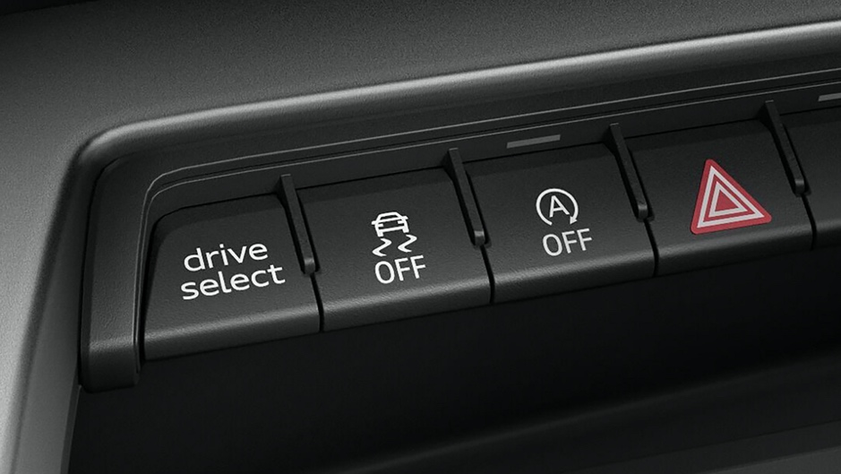
A3 Performance in a Nutshell | EPA-estimated fuel economy (with front-wheel drive)  32 MPG  Standard  LED headlights  Available  quattro® all-wheel drive
 | 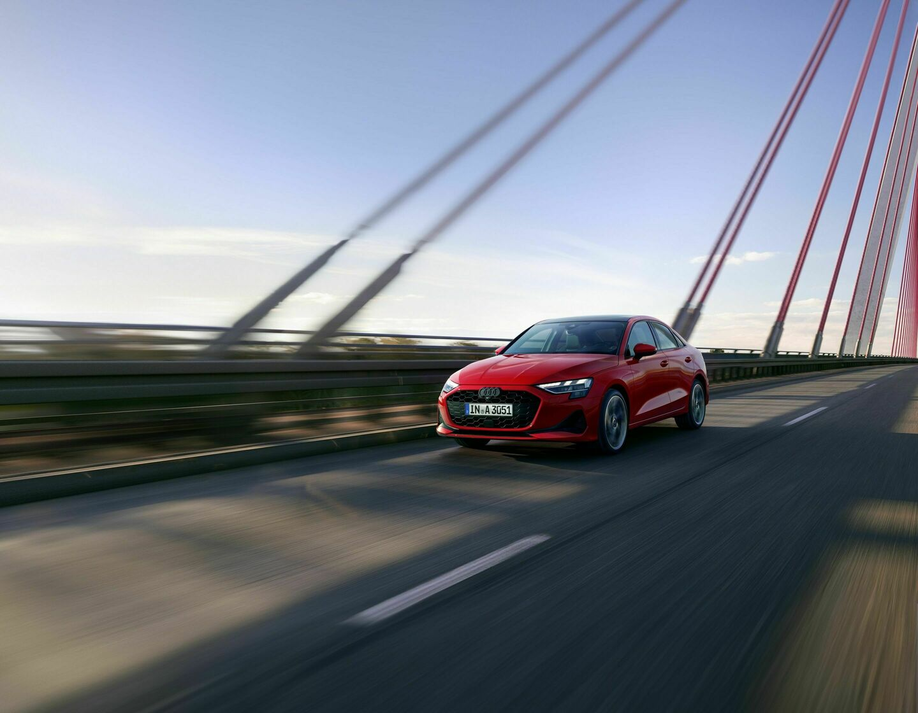
The A3 Mild-Hybrid (MHEV) System | The A3 now comes standard with a 48-volt mild-hybrid (MHEV) system allows the A3 sedan to:  - Coast with engine switched off  - Recuperate (12kW)  - Boost (12 hp/37 lb-ft)  - Improved smoothness of start/stop system  - Improved combined EPA estimated fuel economy by 6 mpg (compared to MY20 A3 quattro)
 | 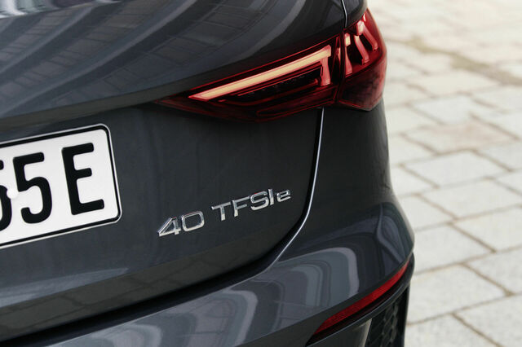
S3 Performance In a Nutshell | Horsepower  306 HP  Torque  395 lb-ft  0-60 mph in  4.5 sec
S3 Suspension | The standard S3 suspension sits at 0.6” lower than the A3 models.  The available S sport suspension with damper control adapts to the road for the best driving experience.  By changing oil flow to the dampers, the suspension immediately adapts to the condition of the road and driving behavior in just a few thousandths of a second.
 | 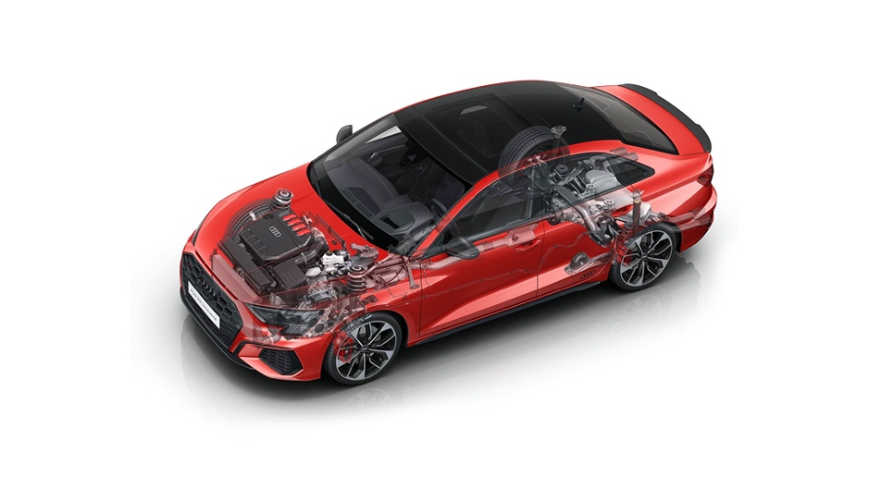
RS 3 Performance in a Nutshell | Horsepower  401 HP  Torque  369 lb-ft  0-60 in  3.6 sec
RS 3 High-Performance Features | The RS 3 has several features that make it a high-performing vehicle:  - RS Torque Splitter  Increases power to the outside wheel. The torque splitter has multi-disc clutches on each drive shaft to make turns faster.  - Sports Suspension Plus  The suspension allows adjustment for road conditions, driving situation, and the drive select mode chosen. It also adjusts the shocks to minimize bouncing, which helps the vehicle corner better.  - New Brake Systems  There are steel or ceramic brakes in the front. Ceramic brakes are more resistant to brake fade because of faster temperature reduction.
 | 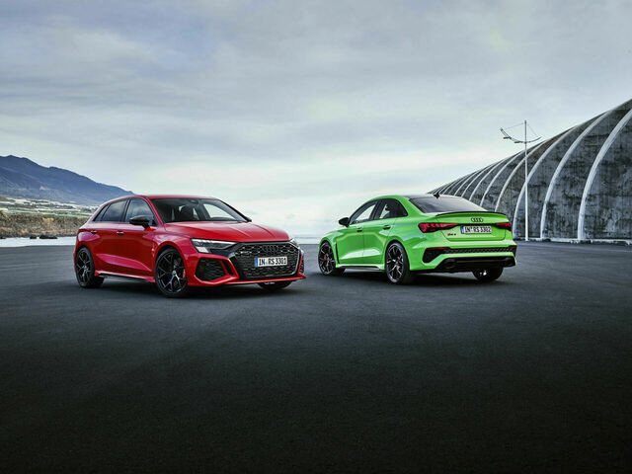
RS Torque Splitter | Video: RS Torque Splitter  Question: What’s a quick way to explain to a customer the advantages of the RS torque splitter?

Technology (top nav item)
Slide | Content
Key Technology Features | Some of the key technologies for the Audi A3 Model familiy include:  - The instrument cluster  - Virtual cockpit plus  - MMI touch display  - Available LED interior lighting plus package
Instrument Cluster | The instrument cluster has two available displays:  10.25” digital instrumental cluster standard  12.3” Audi virtual cockpit plus – available
 | 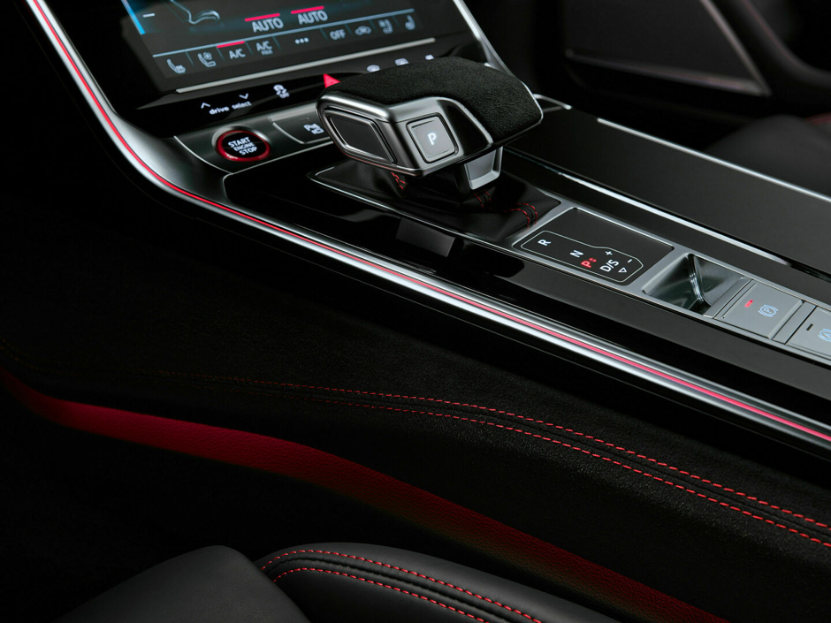
Virtual Cockpit Plus | Virtual Cockpit Plus is a single screen positioned above the steering wheel. It shows more information than conventional displays, allowing drivers to customize the information they want to see.
 | 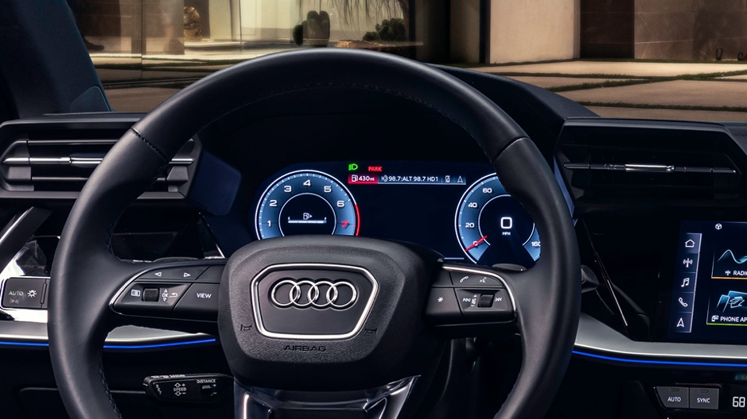
MMI touch display | The 10.1-inch MMI touch display incorporates all functions of the MMI system and can be operated at the touch of a button. The driver can enter text in the search bar with the keyboard (while stationary) or by using their finger to write in their destination. It also includes updated natural voice recognition and the myAudi app, Apple CarPlay or Android Auto.  Complex functions are easy to use. The customer will enjoy an interface that is like their phone. Updated handwriting and voice recognition puts the customer at ease while using the intuitive system.
 | 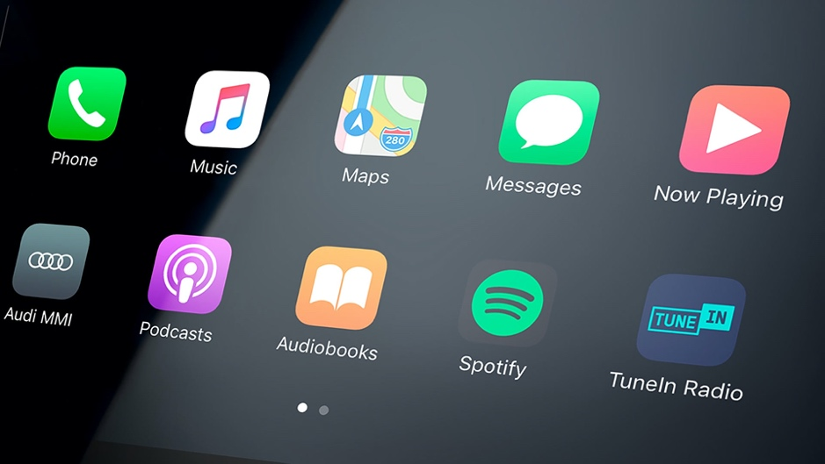
Available LED interior lighting plus package | The interior lighting plus package is available for A3 models, and includes:  - LED lights for the roof  - Door contour lighting in the front and rear  - Ambient door lighting in the front and rear in 30 colors  - Lighting in the storage compartment in the center console
 | 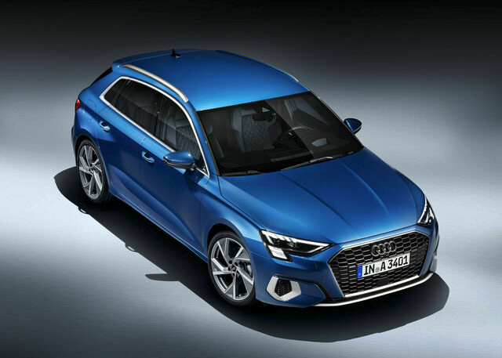
Activity – Name That Customer Benefit
This activity helps participants define the customer benefits of the technology features of the A3 model family.
- Divide the group into teams. Assign a technology feature to each team.
- Ask each team to create a 30-second description of their system that includes at least 1 customer benefit.
- Each team presents their description to the entire group. Encourage enthusiasm and persuasive language.
- After each description, allow brief feedback from other teams.

Driver Assistance (top nav item)
Slide | Content
Driver Assistance systems | Question for participants:  Imagine if you were a customer having to drive long distances on the freeway every day. What driver assistance systems might help that customer?  Facilitate a discussion about the answers to this question.  Some of the most useful driver assistance features include:  - Adaptive Cruise Assist with Lane Guidance (ACA)  - Head-up Display  - Park Assist  - Audi Pre-sense Front
Adaptive Cruise Assist with Lane Guidance (ACA) | ACA automatically maintains distance from the vehicle in front, while the adaptive cruise assist aids steering, braking, and acceleration. Adaptive lane guidance helps the driver to stay centered in the lane. It also has a Stop & Go function for automatic braking to a standstill and under certain conditions it will resume when traffic permits.  Adaptive cruise assist helps the driver by combining distance control from the vehicle ahead and assisted lane guidance.
More About ACA | Video: Adaptive Cruise Assist  Question: What’s the most useful benefit of ACA to a customer?
Head-up Display | The head–up display shows the key information of systems in the driver's field of vision.  Head-up display is customizable and can show:  - Road speed  - Navigation  - Adaptive cruise assist  - Lane guidance  - Traffic sign recognition  - Speed limit info  - Warnings
 | 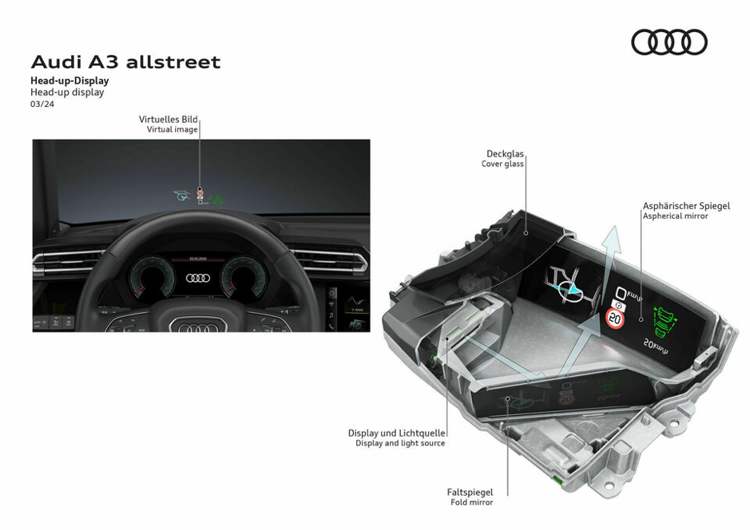
Park Assist | Park assist can identify parallel and perpendicular parking spaces and steer the vehicle into them. Maneuvering in parallel and perpendicular parking spaces is less stressful and more manageable.
 | 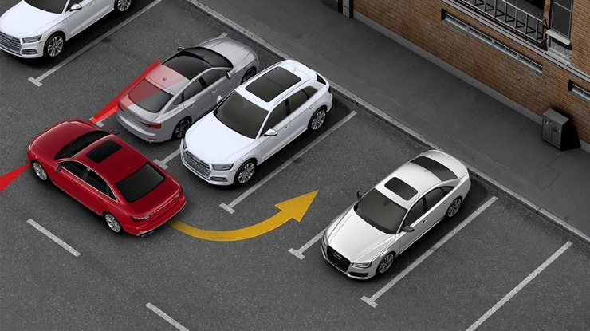
More About Park Assist | Video: Park Assist  Question: How would you explain the benefits of Park Assist?
Pre-sense front | Audi pre sense front uses radar to help monitor the area in front of the vehicle.  Under certain conditions, the system can detect pedestrians or cyclists moving on the road. The system then provides the driver with a warning sequence, if needed.  Every A3 is designed to help reduce the stress of city and traffic driving, giving peace of mind and a reduced risk of collision with vehicles, pedestrians, and cyclists.
 | 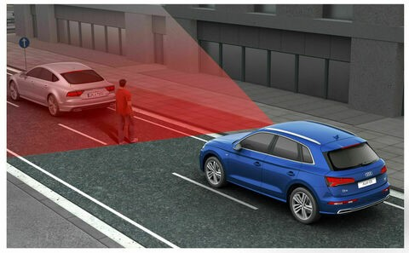
More About Pre-sense front | Video: Pre-sense front  Question: In what driving situations would pre-sense front be useful?  [For Facilitator Instructions, potential answers:  - In heavy traffic  - On a busy street where people are crossing  - On a country road where animals might be crossing]

Demographics and Ownership Experience (top nav item)
Slide | Content
Customer Mindset | Here’s what might be on your customer’s mind when they’re considering their next vehicle purchase:  - I want a feeling of adventure when I’m driving.  - My vehicle is a statement of who I am.  - This vehicle purchase is in the best interest of my family.
The A3 customer  Meet Roz.  She is in her mid-forties, married, with one child. She leads a busy life, balancing her family and her demanding job.  What would appeal to her about the A3? | Demographics:  Gender: 55% female  Median Age: 49  Status: 45% married, 20% with children  Purchase Reasons:  - Fun to drive  - Exterior styling  - Price  - Quality
The S3 customer  Meet Javier.  He’s a busy professional at the peak of his career.  What would appeal to him about the S3? | Demographics:  - Gender: 15% female  - Median Age: 45  - Status: 55% married, 20% with children  Purchase Reasons:  - Fun to drive  - Exterior styling  - Power and acceleration  - Engine performance
The RS 3 customer  Meet Harry. He’s an entrepreneur with a thriving business and feels like it’s time to reward himself for his success.  What would appeal to him about the RS 3? | Demographics:  - Gender: 5% female  - Median Age: 43  - Status: 55% married, 20% with children  Purchase reasons:  - Fun to drive  - Power and acceleration  - Engine performance  - Prestige
Activity – Demographic Dazzle
The purpose of this activity is to help participants create unique selling points for each model.
- Gather everyone in a circle.
- Assign a customer to each participant.
- Ask each participant to share one unique selling point that would resonate with their assigned customer.
- Record these USPs on the whiteboard.

Competitive Performance Comparison | Here is a comparison between the 2023 Audi A3 40 TFSI Mercedes and BMW models:

2023 Audi A3 40 TFSI Competitive Performance Comparison
 | 2023 Audi A3 40 TFSI | 2022 Mercedes A 220 | 2022 Mercedes Benz CLA 250 | 2022 BMW 228i Gran Coupe
Engine type | 2.0L I4 turbo | 2.0L I4 turbo | 2.0L I4 turbo | 2.0L I4 turbo
Horsepower (hp) | 201 | 188 | 221 | 228
Torque (lb-ft) | 221 | 221 | 258 | 258
Acceleration (0-60mph) | 6.6 | 7.1 | 6.3 | 6.3
EPA Estimated MPG (city/hwy) | 4 29/38 (FWD) 28/36 (AWD) | 25/36 (FWD) 25/34 (AWD) | 25/36 (FWD) 24/33 (AWD) | 24/34 (FWD) 23/33 (AWD

Facilitate a discussion answering these questions:
“How would you discuss this information with a customer? What points are the most important to point out?

Resources (top nav item)
Slide | Content
Audi A3 website
Seat Memory Function
Audi A3 Exterior
RS Torque Splitter
Adaptive Cruise Assist
Park Assist
Pre-sense front

Exit Ticket | Standard text

