Resilience in Supply Chain Certificate

Module 4: Secure and Flexible Systems

Module Description
This module discusses how to reinforce the supply chain to be secure and flexible in general and for each of the supply chain systems: manufacturing, distribution, order management, and materials management. Use the information in this module to build a secure and flexible supply chain that continues to operate during outside events or unforeseen circumstances, such as supply chain disruptions or severe weather events.

Overview
Everyone needs products, and businesses need to keep those products stocked and available for purchase. The main way that businesses can consistently provide products and goods is by building a secure and flexible supply chain that continues to operate during unforeseen events.

Secure and flexible supply chains are essential for keeping the economy functioning while delivering goods to customers. Unfortunately, outside events do occur and can disrupt daily supply chain operations, such as product manufacturing, inventory loss, or shipping delays. Acknowledging and accepting that supply chain disruptions are bound to happen is the first step to establishing a resilient supply chain strategy.

All resilient supply chains contain secure and flexible systems that move product inventory around to other locations, escalate orders, expedite shipping, stock more inventory, manage employee schedules, and provide order information on command.

Creating a secure and flexible supply chain relies on an understanding of how to create a general secure and flexible system and how to reinforce the four supply chain systems for resilience.

Learning Objectives
Upon completion, participants will be able to:
- Explain the dynamics of flexibility and security within various supply chain systems and strategies.
- Explain how prevention, contracts, insurance, and data contribute to a secure supply chain.
- Describe how multisourcing and employee training contribute to a flexible supply chain.
- Explain how to build the manufacturing system for resilience.
- Detail how to build different distribution components for resilience.
- Explain how to build the order management system for resilience.
- Describe how to build various material management system components for resilience.

Section 1: The Four Supply Chain Systems

Lesson 1: Defining Strong Supply Chain Systems
Supply chains need to be secure and resilient as holistics systems and within individual components. Every supply chain has four areas of operations that work together to complete the supply and demand cycle: manufacturing, distribution, order management, and materials management. All businesses need a place where they can create the physical product, a way of getting that product to the customer, a way of tracking and modifying orders in real time, and a system that contains all of that data.

These four systems not only need to function well, but they need to be built to be both secure and flexible so that the entire supply chain system as a whole continues to operate during events such as plant explosions, tornado damage, or supply shortages.

Select each button in the graphic below to learn how each system contributes to a strong supply chain system.
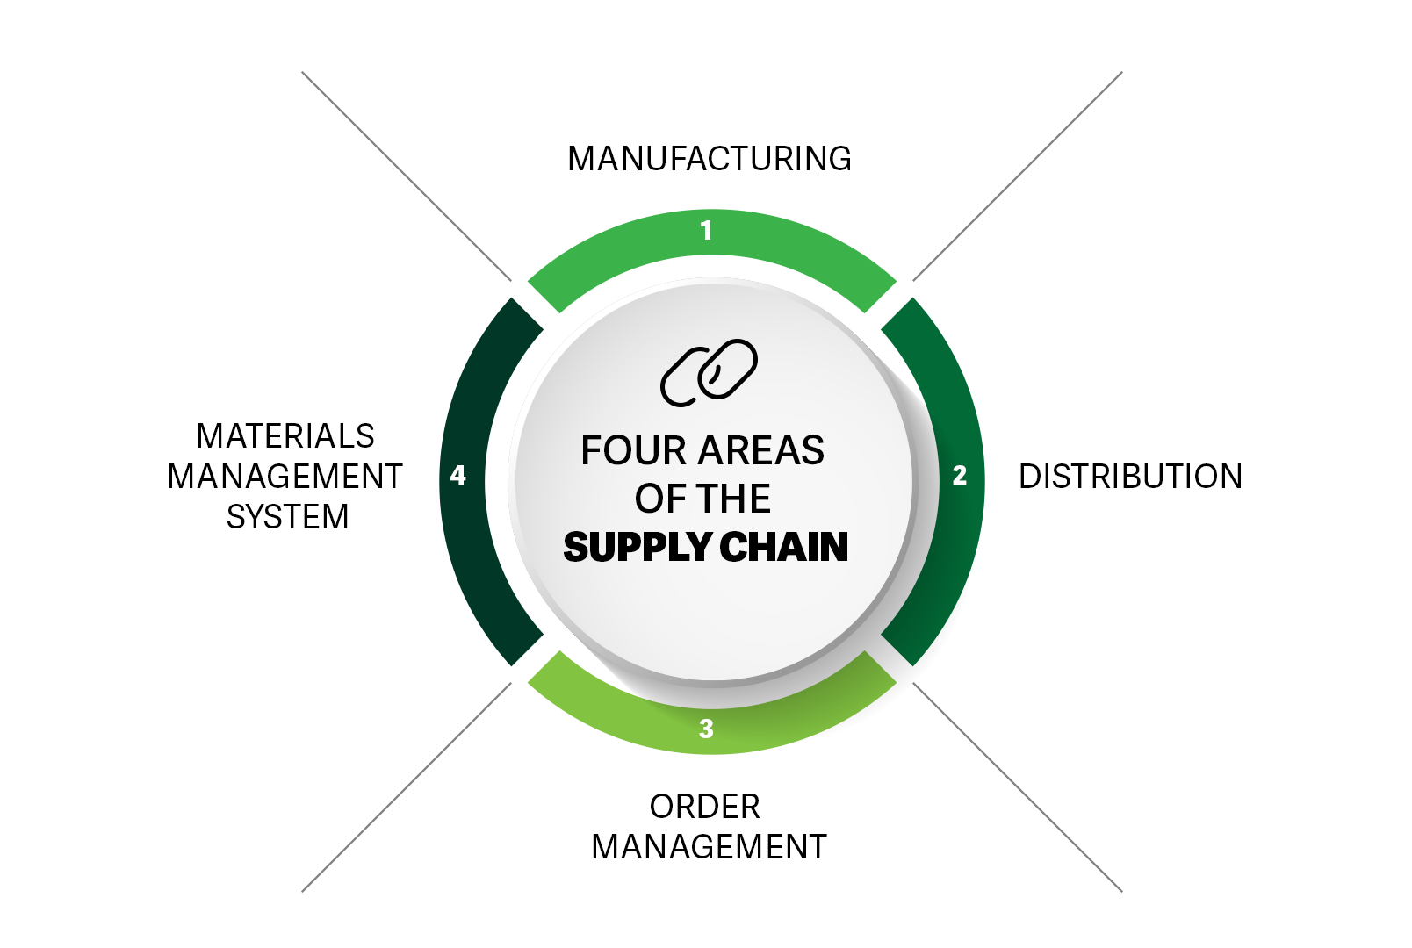

A flexible manufacturing system ensures that there is always inventory available when needed. Building a flexible manufacturing system requires having more than one materials supplier and production warehouse that produce the same products. Multiple suppliers and production warehouses means that the products are still manufactured during unexpected materials shortages caused by shipping delays, lack of supply, inclement weather, or disasters such as an electrical fire or a plant explosion.

A secure distribution system seamlessly moves products to their final destinations in the shortest amount of time. Successful distribution systems use lead time and multisourcing to keep moving product around regardless of outside events, such as inclement weather, train derailment, or truck breakdown. A grocery store, for example, would benefit from owning their own trucks since they move perishable products constantly and consistently.

A flexible order management system effectively escalates, changes, adds, removes, or replaces orders without disrupting normal operations. The software should be able to handle all associated order management operations to meet all of the basic needs, including worker schedules, customer orders, and product tracing, along with strong data analytics programs.

A secure materials management system successfully incorporates dependable management systems that are secure, provide extensive data, and can send alerts about configured triggers such as demand sensing and research reason. The materials management system needs to be ready for a large influx of orders or a sharp decline in need by monitoring and tagging certain materials and products that tend to experience sharp changes in demand.

Lesson 2: How Strategy Contributes to a Flexible and Secure Supply Chain
Choosing a supply chain strategy is the foundation for creating a secure and flexible supply chain. Choosing a strategy determines which materials will be used to create the product, how much of that material is needed, where those materials will come from, how that product will get made and then delivered to the customer. In order to establish a secure and flexible supply chain, there must first be a plan in place as to how materials will get made into product and then shipped to the customer.



Select the play icon to watch the short video below to learn the difference between supply chain strategies and how to choose the one that works best for a business.

Video: Horizontal versus Vertical strategies
Select the plus (+) below to read a transcript of the video.
***********************
Generally, successful supply chains employ one of two strategies: vertical or horizontal. While some companies use a blend, most tend to lean more in one direction. The main difference between a horizontal and vertical strategy is the access to raw materials.
Take an oil refinery, for example. It has direct access to its raw material — oil. The refinery owns the equipment to extract the oil and transfer it to another location, prepare it for distribution, and then distribute it to their contracted facilities. This oil refinery would not need to rely on anyone else to get access to raw materials, to manufacture the products, or to distribute it. They actually save money by owning their own distribution method.
On the other hand, a local specialty supply store, like an arts and crafts shop, wouldn't produce products or distribute them in bulk. A vertical strategy probably wouldn’t work for them. Such businesses likely have several contracts with distributors to carry products in their store. Therefore, these types of companies really focus on order management. While they still need to make sure that they have good contracts with suppliers, manufacturers, and distributors, they’re not responsible for producing the product or getting it to its proper location. This is a horizontal strategy.
What about the businesses out there that use a blend of the two strategies? A great example of this would be a department store. These businesses tend to sell items from multiple manufacturers. For instance, they might carry name brands as well as their own store brand. In this case, the department store would have their own manufacturers to produce their store brand but would rely on other manufacturers to produce and move those contracted products to them.
While this department store likely owns its own distribution system, it generally does not have access to the raw materials to produce mowers, bed linens, clothes, chainsaws, refrigerators, and perfume.
This department store, while having an aspect of itself that can be viewed as vertical, is still primarily using a horizontal strategy. The vertical aspect of creating their own name-brand products is still technically a horizontal strategy, as they are likely ordering the supplies to make those products. They might own their own distribution system, but they still rely on others for manufacturing and materials.
In the end, the strategy you choose — be it vertical, horizontal, or a blend of both — will shape the future of your supply chain. It's not just about saving costs or streamlining operations; it's about building a resilient, adaptable system that can weather any storm.
In a horizontal supply chain strategy, companies collaborate with peers operating at the same level in the supply chain, creating a symbiotic relationship that enhances flexibility and security. For instance, think of two neighboring fruit farms sharing transportation resources to distribute their produce. This collaborative approach allows them to quickly adapt to market demands, showcasing flexibility. If one farm faces a sudden pest infestation, the other can ramp up its supply, ensuring a steady flow of produce to the market, which demonstrates security. By pooling resources and sharing information, they can better navigate challenges and seize market opportunities together. The diversified risk and collective problem-solving inherent in horizontal integration lay a strong foundation for a flexible and secure supply chain.

On the other hand, a vertical supply chain strategy is about having control over multiple stages of the supply chain, from procurement to distribution. Imagine a clothing brand that owns cotton farms, textile mills, manufacturing units, and retail outlets. This end-to-end control provides a bird's eye view of the entire supply chain, enhancing security by enabling better risk management and quality control. For instance, if there's a hiccup in cotton supply, the brand can swiftly coordinate across its units to mitigate impacts, showcasing flexibility. Moreover, with centralized control, the brand can ensure security by closely monitoring each stage for potential threats or disruptions and responding promptly. Through a vertical strategy, companies can achieve a harmonized flow of operations, making the supply chain both flexible in facing market dynamics and secure against potential disruptions.

A hybrid supply chain strategy marries the best of both horizontal and vertical strategies to foster flexibility and security. Imagine a company that collaborates with external partners to diversify its supply sources while also owning some key stages of its supply chain to ensure quality control. This blended approach provides flexibility as the company can swiftly adjust to market changes through its wide network of partners. On the security front, by having control over crucial stages, the company can mitigate risks and ensure a reliable supply chain. The hybrid model thus creates a supply chain that is agile in response to market dynamics and robust against potential disruptions.

Practice: The Four Supply Chain Systems

1. What are the four areas of the supply chain?
- Manufacturing, distribution, organizational management, data systems
- Manufacturing, distribution, order management, materials management
- Production, carrier, order management, materials management
- Production, distribution, order management, materials management
Feedback: The four areas of the supply chain are manufacturing, distribution, order management, and materials management. All companies need to produce the product, get it to where it needs to go, manage orders and inventory, and configure alerts about changes in inventory, order data, and escalations.
Learn more about this topic by visiting the Defining strong supply chain systems lesson.

2. What is the best way to establish a flexible manufacturing system?
- By having one supplier and one manufacturer making the same product
- By having multiple suppliers and multiple warehouses making different products
- By having multiple suppliers and multiple manufacturing sources making the same list of products
- By having multiple suppliers and one manufacturing source making all of the products
Feedback: The best answer is by having multiple suppliers and multiple manufacturing sources making the same list of products. Having multiple suppliers and manufacturers making the same products means that the product is always being made and prepared for delivery.
Learn more about this topic by visiting the Defining strong supply chain systems lesson.

3. Which statement accurately reflects the impact of a hybrid supply chain strategy on flexibility and security?

A. A hybrid strategy lacks both flexibility and security since it neither collaborates with external partners nor controls key stages of the supply chain.
B. A hybrid strategy enhances flexibility by solely relying on external partners for resources, and security by owning and controlling key stages of the supply chain.
C. A hybrid strategy offers flexibility through collaboration with external partners and security through control over key stages of the supply chain.
D. A hybrid strategy compromises flexibility and security by attempting to control all stages of the supply chain and ignoring external collaboration.

The best answer is a hybrid strategy offers flexibility through collaboration with external partners and security through control over key stages of the supply chain. A hybrid supply chain strategy combines the benefits of both horizontal and vertical strategies. Collaborating with external partners allows for swift adaptation to market changes. On the other hand, controlling key stages of the supply chain ensures security, enabling effective risk management and quality control.

Learn more about this topic by visiting the How Strategy Contributes to a Flexible and Secure Supply Chain lesson.

Section 2: Building a Secure Supply Chain

Lesson 1: Foundations of Building a Secure Supply Chain
A secure supply chain requires preventative measures to ensure manufacturing and delivery, data storage and analysis, and protection against external threats like product theft or computer malware.

Building and establishing a secure supply chain involves intelligent prevention measures, robust and clearly outlined agreements with manufacturers and distributors, and comprehensive insurance that covers all aspects of the supply chain, from employees to inventory and data security.

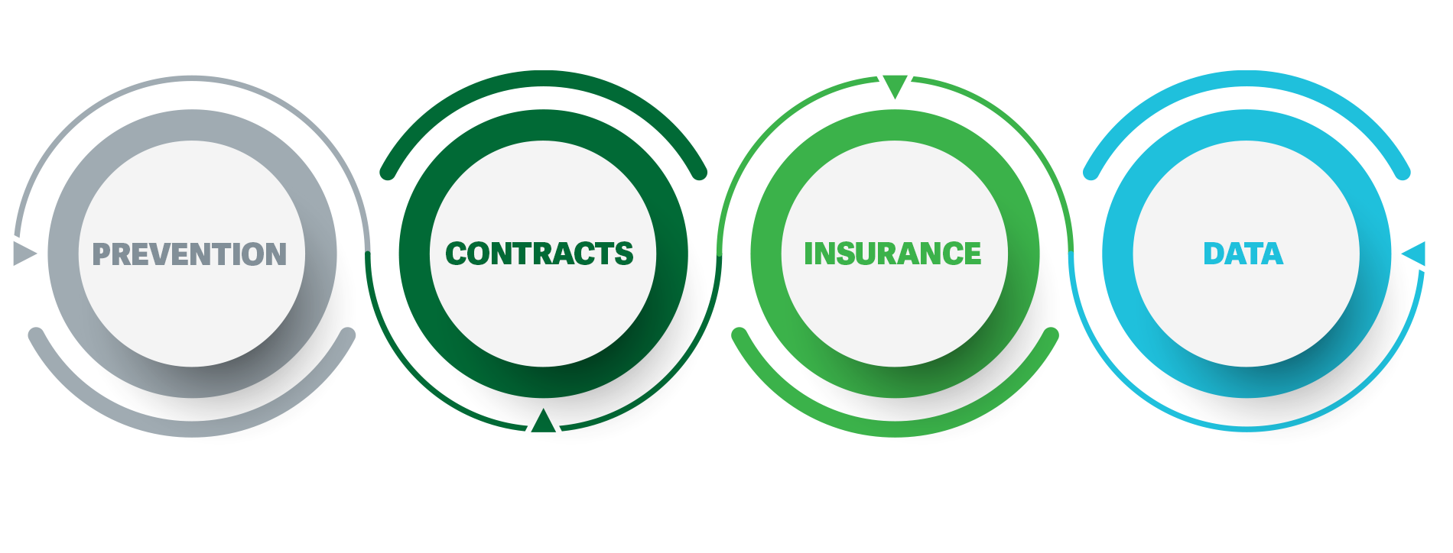

Lesson 2: Using Prevention to Create a Secure Supply Chain
The first step to creating a secure supply chain is to establish preventative measures that safeguard inventory from theft or other external incidents throughout the supply chain. However, the very first action any company should take is conducting disaster drills at all physical locations. It is essential to protect employees, warehouses, and inventory from inclement weather, fire, and other potential disasters, as they are the backbone of the supply chain.

While not all companies need tornado or hurricane drills, all will need to have a fire drill in place. Whether it be an electrical fire, wildfire, or hazardous material leak, a fire can happen at any time and any place.

To protect employees and inventory as best possible:
- Always have a building map that highlights the fire exits.
- Practice fire drills at least once per year.
- Enable a notification system to alert employees and customers to take shelter.
- Carefully store hazardous materials away from busy areas to prevent further damage.

After establishing and enacting a fire drill for employees, there are several other preventative measures to take to protect the product, manufacturing plants, and warehouses.

Select each of the plus (+) signs below to learn more about each of the preventive measures.

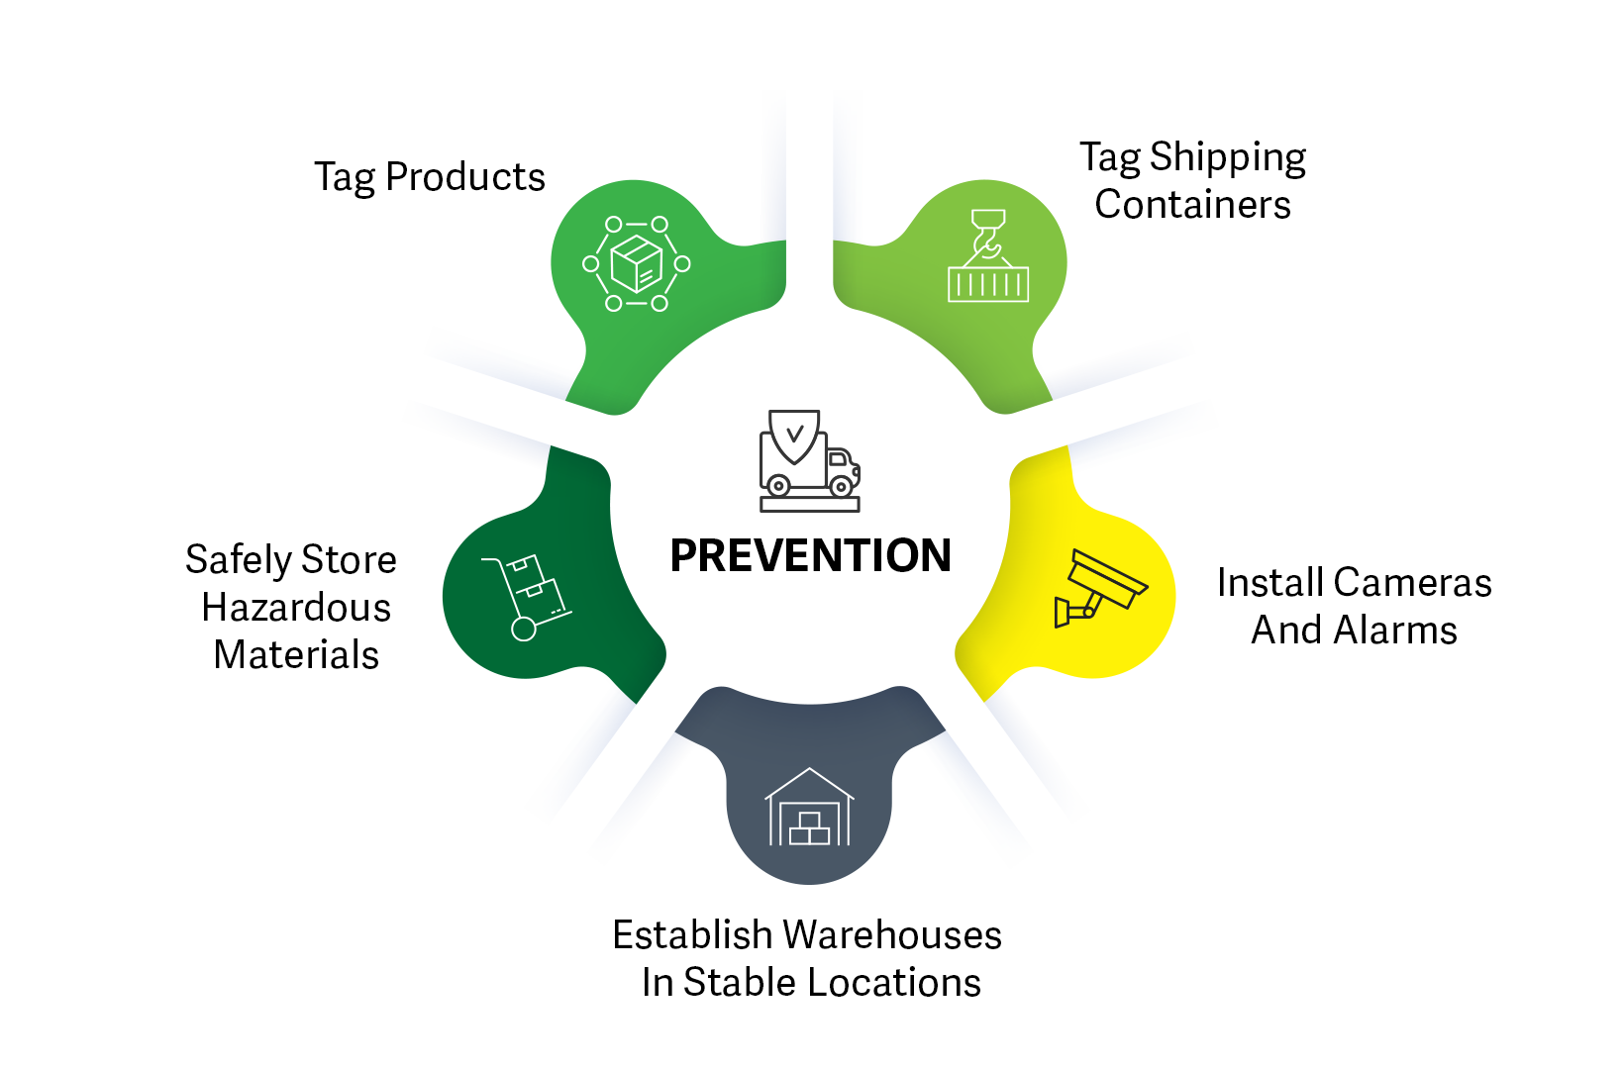

Tag products
Physically tagging the products with a barcode or an active GPS tag monitors the inventory’s location throughout the supply chain. These tags follow the product’s location data, which helps avoid unnecessary stress and panic about when the product will arrive. GPS tags in particular are best at discouraging theft, as the product can be tracked to its specific location. Tag the products on any interior space as much as possible to prevent anyone from removing them during shipping.

Tag shipping containers
Physically tagging the shipping container with a barcode or an active GPS tag monitors the materials in that container. As is the case with tagging products, tagging shipping containers with GPS tags discourages theft, as those missing items can be traced back to their current locations. Tagging the shipping containers also keeps track of how much inventory is in that specific container in case it needs to go elsewhere after it reaches its destination.

Install cameras and alarms
Cameras and alarms can help prevent theft from the warehouses, manufacturing plants, and retail locations. Most people are less likely to steal if they know that their actions can be caught on camera. They are also less likely to steal if they know that a security guard is looking for theft. It is wise to tag desirable inventory, such as brand name clothes or accessories, and to hire security guards to protect the inventory in both the manufacturing and retail locations.

Safely store hazardous materials
The first thing to do is to make sure that the warehouse or manufacturing plant is capable of storing hazardous materials. Hazardous materials require a lot of space that can be reinforced and kept away from daily operations. It is important to take the extra steps to safely store hazardous material in protected locations, ideally behind firewalls and solid structures to help minimize any damage. Ensuring that hazardous materials are properly labeled and stored in a secure location is crucial for the safety of employees in general, as well as during times of disaster or inclement weather.

Also contact the local fire department and provide them with the warehouse layout and hazardous material and storage locations. This essential information helps the fire department navigate around potential dangers in the event of a fire or explosion. Alert the local authorities to the potential dangers of having the warehouse with hazardous materials in their jurisdiction as well. Having both the fire and police departments aware of the operations and contents helps everyone prepare for and safely address any accidents.

Establish warehouses in stable locations
It is best to establish warehouses in stable environmental areas, where possible. Avoid constructing in areas that frequently see tornados, hurricanes, fires, or floods, and always harden the warehouses appropriately for their locations.

Warehouse Hardening
Hardening the warehouse is the most time-consuming but also the most crucial preventative measure to take. Protecting the warehouses means safeguarding the employees first and the inventory next. It's impossible to have an operation without employees or product, and both deserve to be protected as well as they can from severe weather events and extreme incidents like an electrical fire or explosion. Employees, local authorities, and insurance providers should all collaborate on site hardening against natural risks, and companies should conduct safety briefings and drills to prepare for the unexpected.

To harden the warehouse, first start by asking the following questions:
- What is the quality of the site infrastructure?
- Is the location well supported by local utilities?
- Are area fire departments equipped to handle the size of the location and materials stored there?
- Is the road network sufficient and well maintained?
- Is the support structure and framework durable?

Warehouses can be part of a larger regional support system, and the quality of this system affects both how reliably the warehouses operate and how much their insurance costs.

Video: Hardening your warehouse
Select the play icon to watch the short video below to learn more about how to protect your warehouse and its inventory from unforeseen events such as tornadoes, fires, earthquakes, and floods.

Select the plus (+) below to read a transcript of the video.
***********************
Unforeseen events will always happen, often when we least expect it. Whether these events are shipping delays due to inclement weather, or electrical damage from high winds, acts of nature have a way of humbling us. While events such as these are out of our control, we can make a plan and be prepared!
And while being prepared might not completely protect your employees, warehouse, and inventory, you can logically plan warehouse locations and incorporate preventative measures to protect all three as much as possible. Start by asking some of the following questions:
Do we need to be near a water source? Manufacturers that require large amounts of electricity or water would do best near a water source. However, being near a water source does increase your risk of flooding. If you need to be near a water source, it is best to install shelves that are high above the floor and secured with straps to keep the product safe from standing water.

Do you require large, open spaces? Manufacturers or farmers that require a lot of open space, such as a car manufacturing plant or a frozen meat farm, would do best in flat areas. However, open and flat areas are prone to tornadoes. The best thing you can do to protect your employees is to practice tornado drills at least once a year and to have safe locations that are preferably underground or in a durable interior room. The best way to protect your products during a tornado is to either store them safely and securely underground or in a closet with four concrete walls.
Is your warehouse near or on a fault line? If your warehouse does happen to be near or on a fault line, it is best to secure products on durable shelves that are attached to the walls. This will help keep the product as still as possible during an earthquake.
Is your warehouse near the ocean? If your warehouse is near the ocean or in a hurricane-prone area, it’s best to have hurricane shutters installed on every vulnerable opening. You should also store the inventory on high shelves and secure it with straps to avoid any potential flood damage.
After you’ve assessed your warehouse location and outfitted your warehouse for potential weather events, it’s time to harden your warehouse against fire damage.
Because fires can happen anywhere, it’s recommended to post a fire evacuation map of the warehouse in a common area and provide it to the local fire authorities. Your employees should always know where the fire exits are, and your local fire authorities need to know if you have hazardous materials and how to navigate around them.
Also, it’s essential to practice disaster drills once a year so that employees are prepared for actual emergencies. And you should enable a real-time site notification system to alert employees and customers that they need to take shelter during severe weather or fire outbreaks.
Hardening your warehouse is time consuming, but it’s an essential preventative measure to take. Protecting your warehouses means protecting your employees first and your inventory second. You can’t have a successful operation without employees and products. Both deserve to be protected from severe weather and radical events.

Lesson 3: Writing Contracts for Security, Reliability, and Accountability
Contracts are necessary for security, reliability, and accountability. Contracts ensure that the requested needs are always on the suppliers’ and manufacturers’ lists each month and that the products get made as those manufacturers promised that they would make those products by those defined dates. And most importantly, these contracts establish accountability, which provides insight into finding what went wrong and where, and creating a solution to remedy that issue.

Everyone needs contracts no matter what type of business they run, what type of strategy they use, or how often they meet with a supplier or manufacturer. Contracts are essential for formalizing the supply chain footprint as well as securing inventory numbers and lead time. It is also always good to have everything in writing for later reference and accountability.

lead time—A span of time required to perform a process (or series of operations) (ASCM Supply Chain Dictionary).

It is industry practice to standardize contract templates to stay current with supply chain management requirements. Therefore, it is suggested that someone on the legal team reviews the contracts to make sure that everything is defined as it should be. For instance, some manufacturers define lead time as the time it takes to get the materials, build the product, and prepare it for shipping. However, someone who is relying on that manufacturer would view lead time as how long it takes that product to get made and delivered to its final destination. Some companies track transportation cycle time — the time between leaving a warehouse and arriving at the destination. A good lawyer can ensure that the contracts have the right stipulations to ensure that the products get made and delivered on clearly defined terms.

A business that specializes in custom products that require blueprints however, would need to make sure that their contracts have extra clauses in them to protect the intellectual work from theft or misuse. And, of course, that would need to have that same lawyer make sure that the blueprint contracts are more specific, as intellectual property is more difficult to protect in the courts.

A strong, secure, and resilient system contains contracts for every aspect of the supply chain. There should be contracts with the suppliers, manufacturers, distributors, and retailers, as well as contracts with software companies to track and trace all of that information. To fully leverage the contracts, identify how many are needed to build a resilient and secure system, and the type of information that should be in all of those contracts to ensure productivity and accountability.

How many contracts should I have?
There is no set amount of contracts to have, but there should be more than two contracts with suppliers and distributors and one with a software company. Depending on the type of business and the strategy in use, the number of contracts will vary.

For instance, a vertical business would likely only need contracts for their retailer locations and the environment lease on the land. They would not need contracts with manufacturers or distributors, as they are that themselves. However, since they are using the land to make their product, they will need environmental contracts that ensure that they are adhering to environmental standards.

A horizontal business would generally use multisourcing. They would want at least two different suppliers with set times and inventory numbers for all aspects of the supply chain, especially manufacturing and distribution. Generally, having at least two contracts for these two supply chain systems allows the primary supplier to create shared technology components and mature components. For example, an automotive parts business would want a supplier for the shared technology components, such as an electric car battery, and rely on the other contracts to obtain mature products, like a gasoline car battery. These multisourcing contracts also help ensure that the materials and finished products arrive on the agreed time in the contract.

multisourcing—Procurement of a good or service from more than one independent supplier (ASCM Supply Chain Dictionary).

That said, a strong, secure, and resilient system requires at least six contracts, two for each manufacturer or supplier and two for each distributor. There should always be at least one contract with a software company to collect and protect the data, as well as one with a retail location if stocking for in-person shopping. There should also be some contracts with expedited carriers for emergency shipping. It is always better to have more contracts, as the more options there are for manufacturing and distribution, the more secure and resilient the supply chain becomes.

What information should my contracts contain?
It’s always a good idea to have the legal team draft contract templates to ensure uniformity in essential details across all agreements. These templates would include standard information such as the company's name, address, and contact details, as well as a boilerplate section summarizing key legal aspects or required order update procedures.

Expanding on this foundation, each contract should outline crucial logistical elements like order cadence, order frequency, lead time, and inventory ownership. Additional clauses addressing transportation and product changes should also be consistently included.

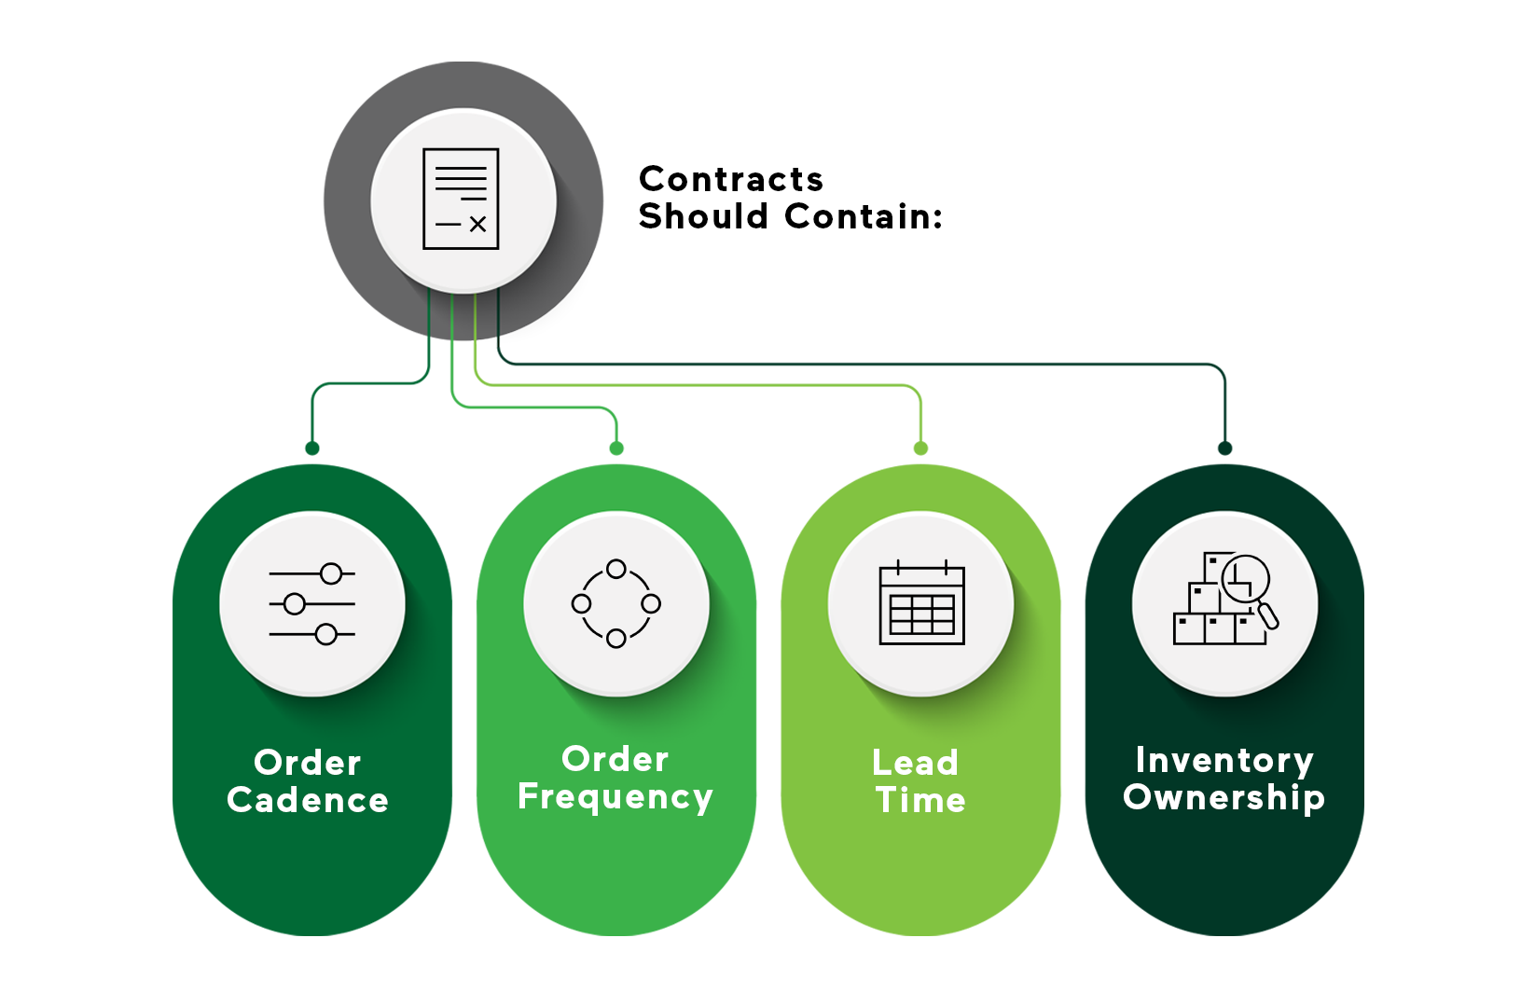

Select each tab to learn more about order cadence, order frequency, lead time, and inventory ownership.

Order cadence
To define order cadence, create a contract that sets what to buy, when to buy it, where it comes from, and how long it will take to reach its final destination. For example, a drug store drafting a contract with a holiday party supplier would want their order cadence to look similar to the following:

What: Holiday decorations
When: Need shipment on the first Tuesday of every Holiday month (March, April, October, November, December), with Christmas coming in November
Lead time: 30 days from order placement to arrival at final destination
How (Distribution): Retailer will provide trucks for transportation from warehouse to retailer

It also helps to define any locations to retrieve any perishable supplies from, such as holiday candy.

What matters most is that the contracts define what is needed, when it is needed, the lead time, and if applicable, preferred distribution locations.
Order frequency
To define order frequency, determine how often to make that product and ensure that those orders are placed at least 30 days before needing the final product. It is best to place orders consistently and at least one month ahead of time.

Defining order frequency maintains expectations between you and the other party as to how much product they should be producing and when to deliver it to its next location.

Lead time
Lead time has various meanings in the supply chain. It can either be the amount of time it takes from order placement to delivery to its final destination, or it could mean the time it takes to place the order, make the product, and ship it out to the business or customer. The ASCM Supply Chain dictionary defines lead time as a span of time required to perform a process (or series of operations). In a logistics context, this is the time between recognition of the need for an order and the receipt of goods. Individual components of lead time can include order preparation time, queue time, processing time, move or transportation time, and receiving and inspection time.

It is important to clarify what goes into the lead time, as many companies have different definitions for their time periods. For example, some companies may define their lead time period as 30 days without clarifying if that 30 days is 30 days from the warehouse to the endpoint, or if it takes 30 days to manufacture and then ship the product. If the contractor defines lead time as the latter, then the contracts will want to add an extra few days to account for transit time to ensure that the inventory gets to its final destination in the expected timeframe.

Inventory ownership
Inventory ownership is when the responsibility of the inventory transfers from the manufacturer or supplier to you. To define inventory ownership, discuss if the ownership transfers to you after it leaves the warehouse, after the product is complete and packaged, or after it gets to the final destination.

Most companies transfer ownership after the product is loaded onto the transportation system. However, that is not the case for every company. Therefore, you may be the full owner of the inventory the instant it leaves the warehouse. In that case, make sure that the insurance covers inventory loss as well as reliable transportation. Also make sure that someone at that warehouse can tag the products before loading them for shipment. It is always essential to tag inventory and have insurance in place before transferring inventory ownership to you.

Lesson 3: Buying Insurance
Buying insurance financially protects the employees, manufacturing plants, and inventory. But first and foremost, buy insurance for the employees. Remember that employees are likely making less than average an hour to stand in an overheated warehouse for eight to ten hours a day for six days a week. These types of conditions are bound to bring on fatigue and heat stroke in the hot months. There is also dangerous manufacturing equipment that can cause serious injury, especially if the employees are tired or fatigued from overworking hard labor jobs.

These workers also likely do not have paid time off and need to come in sick to feed their families. Yet, these workers are the entire reason that the product gets made and gets delivered to where it needs to go. The least you should want to do is protect them from health problems, in the case of those working near asbestos and other harmful chemicals, and physical injury from dangerous machinery. This insurance should allow those employees to be protected from the general dangers of these manufacturing jobs and provide them the time off so that they can heal without fear of losing their jobs.

All businesses need employees. Make sure that they are covered for health insurance, medical leave, and if possible, try to give them some paid sick leave. Paid sick leave allows employees to rest and recuperate at home and prevents them from getting coworkers sick. The extra cost of giving paid sick leave is more efficient than losing half of the staff to a virus.

There also needs to be insurance on all manufacturing plants, storage warehouses, and inventory. Having insurance for the manufacturing plants and storage warehouses ensures that the business does not lose as much inventory or revenue during an uncontrollable event such as a tornado, earthquake, or flood, or a workplace accident such as plant explosion, electrical fire, or heavy machinery collision.

The insurance on the inventory prevents money loss in the event of theft, damage, or missing shipments. Businesses generally need to pay extra to make up for delayed shipping or lost items. To cut those costs, get insurance on all inventory. It’s a good way to recoup some money in case something happens, such as a blocked canal, port explosion, trucking accident, mass theft, or train derailment.

It is essential to make sure that the insurance on the employees, warehouses, manufacturing plants, and inventory is all current, covers what is needed, and reflects the current scope of operations and risk tolerance.

Lesson 4: Protecting Data
There should be a contract with a software company to purchase an enterprise resource planning (ERP) program for collecting and analyzing all supply chain data. Collecting and analyzing data helps predict ongoing and future supply chain costs as well as identify potential issues. Comprehensive data provides insight into measuring product and shipping costs and finding root causes for major cost overruns and customer service disruptions. While collecting and analyzing data builds a stronger resilience strategy for the business, it is necessary to protect that data from outside threats such as computer viruses and hackers.

Gathering and evaluating data through an ERP program greatly strengthens the resilience strategy of our business by enabling more informed decision-making. However, this asset can turn into a liability if not adequately protected from external threats such as viruses and hackers. One method to enhance this security is the concept of a digital twin.

digital twin—an exact virtual replica or model of a real-world process, product, or service used to digitally simulate, test, model, and monitor it (ASCM Supply Chain Dictionary).

While having a digital twin offers a safety net for data recovery and business continuity, it's crucial to implement a multi-layered cybersecurity strategy to defend against viruses and hackers. Setting up the ERP program to generate daily snapshots stored on a secondary server is one component of a broader strategy that should also encompass firewalls, encryption, and additional security measures. This digital twin backup allows the IT department to erase all data in the production environment if it becomes susceptible to external hackers and viruses. Deleting the data from the production system aids in safeguarding both the data and customer information by removing it from an accessible location. After addressing the virus or hack, recreate the production environment using the data stored in the digital twin.

There are also extra steps to take, such as multi-factor authentication (MFA), to help ensure that the data is protected during normal operations. MFA requires the employees who access and review any type of data, such as analysts, HR personnel, or customer support and customer success leads, to enter their information on the computer and verify their identity through a third-party application that connects into their work computer.

The last step that will help protect the private data is to train employees on how to spot hacking and phishing emails. A good way to train employees is to first send an email telling them what they need to look out for and to report any emails or spam text messages to the IT department. Then, within the next few weeks, send out false phishing emails and see who opens them and who reports them. Ideally, everyone will forward these phishing emails to IT. If the staff still struggles with identifying these threats, consider creating a short course for them to take.

Video: Collecting and protecting data
Select the play icon to watch the short video below to learn more about how to collect and protect your data to establish a secure and flexible supply chain.

Select the plus (+) below to read a transcript of the video.
************************
Data is an essential part of any business. It helps us understand how much product we need, who is buying the product, and how quickly our products leave the shelves. We also look at which warehouses have the best product output and which distributors are most often used.
Comprehensive data also allows us to gauge employee performance, fix efficiency issues, and prepare employee schedules. One of the greatest benefits of having data is the ability to know where your product is in the supply chain.
To collect this data, it’s recommended that you meet with at least three suppliers to find the best ERP software for your needs. Ideally, your software program will continuously collect data and compile reports at the end of each business day.
When you install the software, configure it to collect certain information and run it on the production server. You can then use this data to determine crucial factors such as current trends, customer reviews, estimated versus actual production and lead time, as well as order frequency.
While data is a necessary aspect of any flexible supply chain, it must be protected from system hacks, viruses, or unexpected shutdowns.
Now that we know why we should collect data and that we need to protect it, let’s talk about how to secure your data using a disaster recovery plan. The last thing anyone wants is to lose data or to leave it vulnerable for hackers and viruses.
To create a data recovery plan, you’ll first want to create a digital twin. A digital twin is a program that takes a snapshot of your data at the end of each day and stores it on a backup server. Digital twins allow you to delete data on the production environment to prevent hackers from accessing it while maintaining the most recent data in a safe environment.
Even though a computer automatically copies the data to a digital twin, it’s strongly suggested that you teach your employees how to manually copy data over in case of an outage or a failure.
It’s also a good practice to create extra layers of security for specific data, such as HR information, cloud data storage, and software licenses, by using multi-factor authentication or MFA. MFA requires your employees to enter their password on the computer and verify their identity on a second source, like a phone application.

The last step to creating a secure data system is to educate employees on potential security risks, such as email spam and phishing attempts. You can train employees to detect these malicious emails by providing examples of scams and phishing emails or texts so that they know which messages to report. You can also send out false phishing emails to employees to train them on email and text threat detection.
Don't forget, it's not just about collecting and analyzing your data — make sure you're also safeguarding both your team and your data from external threats. Stay vigilant!

Practice: Building a Secure Supply Chain
- What are the four concepts needed to build a secure supply chain?
  - Contracts, data, insurance, prevention
  - Data, lead time, hardening, insurance
  - Insurance, data, order cadence, inventory ownership
  - Insurance, prevention, data, hardening
Feedback: The best answer is contracts, data, insurance, and prevention. Take preventative measures to ensure that the products and employees are protected; protect data from hackers and viruses; sign contracts to ensure productivity; and get insurance to protect the assets.
Learn more about this topic by visiting the Foundations of Building a secure supply chain lesson.

- How do you define order cadence in a contract?
  - By defining what to buy, when to buy it, where it comes from, and how long it takes to reach its final destination
  - By defining how often the manufacturers and the suppliers will meet to discuss logistics
  - By defining how often the distributors and the suppliers will meet to discuss logistics
  - By defining what you buy, when you buy it, how much it costs, and how long it takes to make the product
Feedback: The best answer is by defining what to buy, when to buy it, where it comes from, and how long it takes to reach its final destination. While it’s important to know the logistics of manufacturing and distribution, you do not need to meet with the manufacturer or distributor on a regular basis. Define these terms in the contracts with both the manufacturers and distributors so that all parties understand what is expected of them.
Learn more about this topic by visiting the Writing contracts for security, reliability, and accountability lesson.

- What should the IT department do in the event of a virus or hack?
  - Shut down the system and contact the software company.
  - Pause the system and contact all employees and customers.
  - Shut off the production environment entirely and use the digital twin until the threat is resolved.
  - Shut off the production environment, use the digital twin until the threat is resolved, and update employees and customers about the situation.
Feedback: The best answer is shut off the production environment, use the digital twin until the threat is resolved, and update employees and customers about the situation. The digital twin takes a snapshot of your data at the end of each day. This backup data is especially useful in the event of an outage or a hack.
Learn more about this topic by visiting the Protecting data lesson.
- What is the first thing that all businesses should do after establishing a warehouse or production location?
  - Assess and reinforce any warehouse weak points.
  - Train employees on how to clock in and out.
  - Establish a fire response plan.
  - Contact the local authorities to discuss the new location.
Feedback: The best answer is to establish a fire response plan. Fires can happen without warning. It’s best to assess the warehouse and establish a fire response plan before hiring employees. Learn more about this topic by visiting the Building a secure supply chain overview lesson.

Section 3: Building a Flexible Supply chain

Lesson 1: Optimizing Flexibility with Multisourcing and Employee Education
A flexible supply chain typically relies on multisourcing and employee education to maintain operations during disruptions. Multisourcing provides multiple options for production and shipping, and employee education cultivates a flexible and cross-trained workforce.

While some organizations try to avoid multisourcing due to costs, spending the money on having multiple manufacturers and distributors is one of the best ways to build a flexible and resilient supply chain. Let’s say that you manufacture and distribute toilet paper. Toilet paper is a hot item that tends to be on most people’s weekly or monthly grocery list. If there is only one manufacturer and one distributor, the product will take an incredibly long amount of time to get to the stores. And if the main manufacturing plant shuts down for inclement weather, annual servicing, or other unforeseen events, then those are extra weeks where the product is not stocked or bought off the shelf. Considering that toilet paper is a regular commodity for most people, you would want to manufacture this product at multiple locations with multiple distributors to get the product available to the retail locations.

A flexible and resilient supply chain also includes informed employees. While it costs money and time, ensuring that the employees understand the operation and why their role is important allows employees to move to other workstations while using little extra time to train them. Always remember that the employees are the reason the company can manufacture and distribute products, so while the workforce should be educated and flexible, it’s more important that they are comfortable with the amount of work put on them.

Lesson 2: Using Multisourcing to Create a Flexible Supply Chain
Multisourcing helps maintain product availability even when disruptions occur. For effective multisourcing, collect and analyze data to identify products that either experience high turnover—either consistently or seasonally—or create problems when unavailable. Once you've pinpointed key inventory items, establish contracts with various manufacturers to ensure their production.

Having one or two alternate manufacturers for less critical products is OK because demand can often be met through expedited shipping. Crucial products, however, will cost more money in delays and customer remediation, so it is best to maintain consistent production and distribution for those products. It is also a good idea to have some extra product. Not enough product means rushing to place orders and get the products made and delivered, which causes stress on the manufacturers and distributors. The last thing any business wants is to lose contracts with those manufacturers and distributors because they were ill-prepared for their customer’s demands.

Having multiple manufacturers ensures that the product is always being made, and supply chain alternatives, such as rail, plane, or truck, in addition to standard delivery methods, allow for expedited shipping by moving product to a truck instead of a railcar, or to an airplane instead of a boat. Flying is the most expensive method, but it is an excellent alternative for expedited shipping. It is possible to fly products to almost anywhere in the world within 24 hours. If an order was lost or broken during shipping or stolen at the door, that replacement should be out to the customer immediately. While ground and rail transportation are great for standard operations, they will add an extra week or two to the delivery time. However, if there is a contract to hold a spot on an expedited shipping plane, use that space at any time and for any thing. Try to use that space as often as possible to move any inventory around quickly.

Schedule expedited transportation slots with carriers to have it when needed as well. This strategy saves some money by using only the space that is needed instead of owning an entire plane.

Lesson 3: Educating Employees on Operations and Values
Educating employees fosters a flexible and well-rounded team. Training all employees to understand the full scope of the operation—from production processes to customer feedback evaluations—they gain a deeper understanding of how their individual roles contribute to the larger organizational goals.

To diversify skills within a team, consider cross-training employees in various aspects like production, distribution, data entry, and human resources. This approach not only enables employees to explore roles that align with their interests, but it also prepares them to step into different functions when needed. A good way to introduce employees to these varied roles is through educational resources like presentations or videos. After this, executing a rotational training program across different stations can offer employees practical experience, from running manufacturing equipment to participating in data analysis.

It is essential to remember that not all employees love to do employee training, so try to make it fun by creating some team-building challenges and offering rewards and recognition to encourage employee involvement and enjoyment. One thing to consider is that it can be difficult for employees to sit in one location for an extended period of time. Breaking these training sessions into small, digestible sessions that cover operations and employee values as well as what to do in a severe weather event or other unforeseen circumstance maintains employee engagement.

It is also important to remember that the business would not be able to run without employees. So while it is necessary to have a strong and cross-trained workforce, do not demand too much out of them. For instance, it is not a good practice to have one person doing more than two different large tasks on the same day. However, creating rotating workstations so that the employees can do a different task every day can help prevent them from overwork and boredom on one station as well as train them on all of the operations in case someone calls out or something else happens.

The goal is to be able to adapt to unforeseen situations while maintaining a happy, rested, and alert workforce. However, many companies try to push more than is possible on employees to save money. Take, for instance, a software company that, instead of hiring a new employee when one quits, expects their employees to learn a new job and then simultaneously do both jobs. This business now has a programmer who is also expected to run quality assurance tests, something that they are not trained to do as it is an entirely different role than programming software. This programmer is now tired and angry because they make the same amount of money while performing two entirely different jobs.

Expecting and forcing employees to consistently take on multiple roles is a useless strategy that leads to frustrated and tired employees. They are frustrated because they are likely not paid to do the work of two people, and tired because they are doing the work of two people. At the end of the day, this employee is either likely to hurt themselves from being too tired to work, in which case there could be a lawsuit, or they will quit to be treated better elsewhere. Either way, pressuring employees too much is going to hurt no matter how cost effective it appears. That said, firing staff to save money, or expecting staff to consistently do the work of more than one person is destined to fail.

Train employees so that they are capable of working all of the workstations in case someone calls out or there is a staff shortage. The goal is to make sure that all roles are covered when they are empty, not make all employees do twice the work on a regular basis. There is a delicate balance to building a cross-trained workforce and abusing the workforce. Make sure that everyone can cover other roles, but only make them perform two roles on an as-needed basis. After all, the last thing any supply chain needs is an employee strike over preventable problems.

Practice: Building a Flexible Supply Chain

- What is the best way to encourage employee engagement?
  - Provide challenges, rewards, and recognition
  - Offer time off and extended lunches
  - Offer to take all employees out to lunch for training sessions
  - Force them to participate or lose their job
Feedback: The best answer is to provide challenges, rewards, and recognitions. Manufacturing jobs can become monotonous at times. To encourage employee engagement, offer them something fun to do that also allows them to shine. This method can spark new life in a tired workforce.
Learn more about this topic in the Educating employees on operations and values lesson.
- What is the best way to create a knowledgeable workforce?
  - Train employees on where they fit into the overall production.
  - Train employees in other areas of the company.
  - Test employees on their knowledge of your company.
  - Provide skills tests for employees to pass on a regular basis.
Feedback: The best answer is to train employees on where they fit into the overall production. A knowledgeable workforce understands the process from start to finish and how their specific role fits into that production. This knowledge enables them to assist in issues at any point during the process as they know how each role affects another.
Learn more about this topic in the Educating employees on operations and values lesson.
- Why is multisourcing important when building a flexible manufacturing system?
  - It helps ensure that you have extra product.
  - It helps ensure that your system still runs with backup sources if primary sources run into issues.
  - It helps create good business relationships.
  - It helps market the business to others.
Feedback: The best answer is that it helps ensure that the system still runs with backup sources if primary sources run into issues. Having multiple options helps manufacturing and shipping continue even if one of the primary manufacturers or distributors runs into any issues.
Learn more about this topic in the Using multisourcing to create a flexible supply chain lesson.

- What is a good strategy for teaching new employees?
  - Provide a presentation and have them rotate through a workstation circuit.
  - Have them train on each role for one week.
  - Give them online courses and assessments.
  - Have them sit through a three day training session.
Feedback: The best answer is to provide a presentation and have them rotate through a workstation circuit. Employees should know the company values and how they fit into the overall operation. However, most employees like to be active. A short presentation combined with an interactive circuit helps keep everyone alert and engaged.
Learn more about this topic in the Educating employees on operations and values lesson.

Section 4: Building the Manufacturing System for Resilience

Lesson 1: Key Components of Resilient Manufacturing

There are seven key components that form the backbone of a resilient manufacturing system: product identification, material identification, multisourcing, employee shifts, automation, inventory buffer, and storage space.

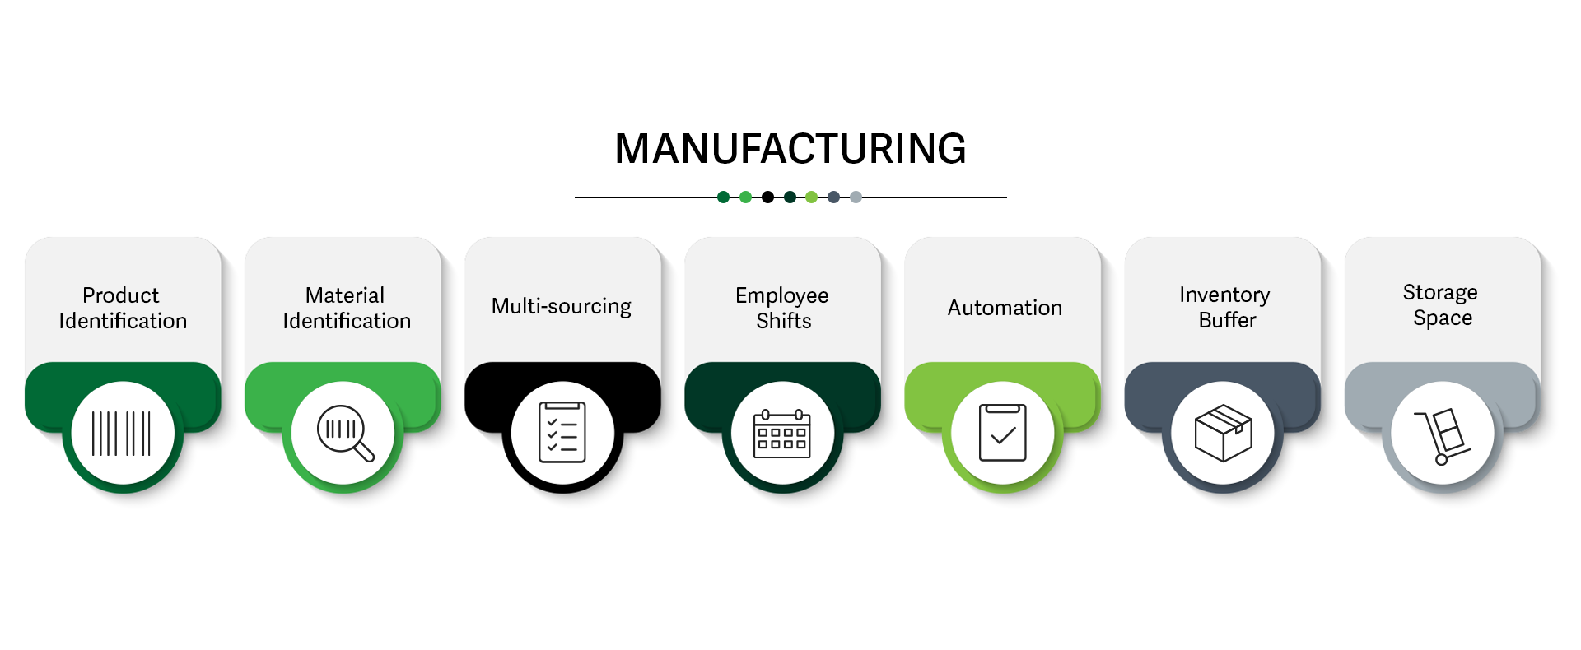

To fortify your manufacturing operations against unforeseen events, it's crucial to comprehensively understand the product you're creating. Think about what is needed, when it’s needed, and where it's needed, and who needs it. By taking these factors into account, you'll ensure your business is well-equipped to meet demands and adapt to unexpected situations.

Now, let's delve a little more into each of the manufacturing components.

Lesson 2: Production Identification
First, determine what the product is and if that product is consistently made and sold. For instance, a soda manufacturing company needs to produce, bottle, and ship their products to multiple retailers on a consistent basis, while a home building company bases their supply needs on the agreed contract. There are also companies that build large assembled products like refrigerators and stoves who do need to produce in bulk, but their products are not bought as frequently as sodas. Then there are process manufacturers who are producing and moving large amounts of goods through a defined system, such as coal on rail or oil through pipelines.

The first step to building a flexible and secure manufacturing system is is determining the manufacturing method required for your products. There are four primary categories: make-to-stock (MTS), make-to-order (MTO), and assemble-to-order (ATO). Understanding these requirements beforehand enables you to optimize the design and operational logistics of your manufacturing facilities.

make-to-stock (MTS)—a production environment where products can be and usually are finished before receipt of a customer order.

make-to-order (MTO)—a production environment where a good or service can be made after receipt of a customer’s order.

assemble-to-order (ATO—a production environment where a good or service can be assembled after receipt of a customer’s order.
(ASCM Supply Chain Dictionary)

Heavy and consumable MTS products like soda bottles generally need multiple plants throughout the county and near water sources for quick manufacturing and distribution. Speciality MTO products, such as homes and furniture, need less manufacturing plants as their supply needs vary depending on the project, but require more contracts with suppliers that work with the fluctuating needs. Large ATO products, such as cars, appliances, and restaurant equipment need larger manufacturing plants in fewer locations but with multiple distribution methods.

Process manufacturers require specialized plants, storage, and materials movement such as pipelines, barges, oil refineries, and steel mills.

Lesson 3: Material Identification
After determining the type of product, space, and location needed to build those products, start identifying the materials that the products need and how to get them. Most businesses would need a supplier to send those materials to the manufacturer. However, this situation is not always the case. For instance, a company that has access to raw materials would only need to sign contracts with the local state authorities to abide by the environmental contracts to maintain a sustainable resource.

Companies that do not have access to raw materials need to identify the supplier infrastructure that exists in the area and determine what to source locally or long distance/offshore. Local products tend to be more expensive but generally have lower shipping costs, while distant materials are typically cheaper but have higher shipping costs. It is best to make a cost versus time tradeoff analysis to determine which strategy is best for the company.

A MTS manufacturer would do better with sourcing distant materials since they tend to buy their supplies in bulk. A soda company would likely buy their supplies in bulk while still producing and distributing sodas to their retailer locations. Since they are already consistently making and shipping products, the longer delivery times rarely interfere with daily operations.

A MTO manufacturer would need a local resource that they can pull from when they need to fulfill a contract. For instance, a home building company would want a local lumber, roofing, and windows supplier that adjusts to their varying needs. A furniture store owner would want a local leather supplier to build a custom chair because they need high quality materials in a short amount of time.

An ATO manufacturer would want an effective local supplier footprint to enable timely delivery times to manufacturing lines. An automotive plant would want to get their supplies from a local source as the parts are generally large and would cost less to transport from the supplier to the manufacturing plant.

A process manufacturer already knows where their supplies are coming from, so they need to determine how to get their products to their final destinations.

Speciality manufacturers might require contracted manufacturers and outside logistical support.

Lesson 4: Multisourcing, Employee Shifts, and Automation
Remember, cultivating a flexible and secure manufacturing system calls for a comprehensive approach. Multisourcing allows for continuity in product supply, even when facing disruptions at one facility. Effective management of employee shifts ensures a balanced and satisfied workforce that can adapt to varying production needs. Incorporating automation not only improves productivity but also enhances worker job satisfaction. These elements collectively contribute to a manufacturing framework that is both secure and agile.

Using multisourcing to build a secure manufacturing system
Using multisourcing to manufacture the same product at multiple plants helps ensure that the product is still being made when the primary warehouse shuts down either for yearly maintenance and/or inclement weather. Always manufacture the most crucial products at multiple plants so that the top-selling goods are always available.

Multisourcing also helps establish local sources to produce or store critical items to quickly backfill any items that sold out quickly or got lost during shipping.

Managing employee shifts
Remember that employees are the most crucial part of any operation. No one can manufacture a product or ship it to another destination without employees. To make sure that the employees are not only taken care of financially but also have a reasonable work-life balance, it is best to add or extend worker shifts to create a balance for employees.

To accommodate employees and employee shifts, first identify the busy seasons and accommodate shifts among employees so that each one has the time they need off in order to work the overtime hours. Also rotate employees on the schedule so that they can have a break in between long days.

Employees need to be well-rested and taken care of, especially in the manufacturing and distribution industry. Many worker strikes have occurred because of long hours in dangerous conditions for not enough pay. A company should know through strong data analysis when there is a need for more employees to cover these busy times. While it might cost more to hire temporary workers for these busy seasons, it is a strategy to consider to keep workers safe and happy.

It is better to have a strong, healthy, and happy workforce that costs a bit more money than to have a tired, exhausted, and angry workforce that does not care about the operation.

Using automation in manufacturing
Use automation, if possible, in the manufacturing and storage warehouse facilities to help ease the work of the employees as well as ensure timely process execution. Ideally use automation to help the employees perform their tasks more efficiently. For instance, a fruit packaging plant could implement an assembly line with automated machinery to help employees separate the fruit and package it for distribution. In this example, the employee works with automation to efficiently produce a package of strawberries or a bag of grapes.

Lesson 5: Inventory Buffer and Storage Space
Maintaining a flexible and secure manufacturing system involves strategic inventory and space management. An inventory buffer acts as a safety net, providing a cushion for unexpected spikes in demand or disruptions in supply. Coupled with this, well-planned storage space enables swift distribution of seasonal or high-demand products. Together, these components facilitate a robust system that can rapidly adapt to market fluctuations and logistical challenges, ensuring both security and flexibility in your operations.

Using an inventory buffer
The inventory buffer is the safety net to use in desperate times of need. For instance, if a large order comes in or the shipment goes missing, use those products in the inventory buffer to maintain lead time and customer satisfaction without disrupting the manufacturers and suppliers.

Also, create an inventory buffer for any products that create significant manufacturing or customer service issues when out of stock. If, for example, the business sells starter logs for the fireplace, the retail locations would want extra stock for the winter season. While the retailer might not sell all of those starter logs, they will at least have enough product available at their location.

It’s wise to run and analyze the data in the ERP to estimate how much product the company will need during the busy seasons and add an extra number of products to accommodate for an uptick in sales. The most important thing to remember is to always refill the inventory buffer after using it.

Using storage space
Establishing storage space in an accessible location, especially if there are several products for one season, helps quickly move ready products to local retailers. Analyze how much product is needed for different seasons to determine the size and location for the storage space. For instance, a party supplies manufacturer would benefit from having a local storage space to house seasonal items, such as Halloween and Christmas decorations, to quickly move those products into the stores when they change over for the season.

While this storage space costs extra, it helps quickly restock highly desirable items, such as toilet paper or dish supplies, and stock seasonal items quickly and efficiently.

Practice: Building the Manufacturing System for Resilience

- What is the primary role of an inventory buffer in a resilient manufacturing system?
A) To create employment opportunities
B) To help in the quick distribution of seasonal items
C) To act as a safety net for unexpected spikes in demand or supply disruptions
D) To reduce shipping costs

Feedback: The best answer is to act as a safety net for demand spikes or supply disruptions. An inventory buffer acts as a safety net, providing a cushion for unexpected spikes in demand or disruptions in supply. This ensures that the manufacturing system remains resilient against unexpected situations.

Learn more about this topic in the Inventory Buffer and Storage Space lesson.

- Which component is crucial for maintaining a balanced and satisfied workforce in a manufacturing setting?
A) Multisourcing
B) Material Identification
C) Managing employee shifts
D) Storage Space

Feedback: The best answer is managing employee shifts. Effective management of employee shifts ensures a balanced and satisfied workforce, which can adapt to varying production needs. A well-managed workforce is key to the resilience of a manufacturing system.
Learn more about this topic in the Multisourcing, Employee Shifts, and Automation lesson

- What is the significance of material identification in a manufacturing system?
A) To determine the manufacturing method
B) To facilitate local distribution
C) To help in building customer relations
D) To identify the type and source of required materials

Answer: The best answer is to identify the type and source of required materials. Material identification helps in understanding the type and source of materials required to manufacture a product. Knowing this aids in planning the overall sourcing and manufacturing strategy, which contributes to system resilience.
Learn more about this topic in the Material Identification lesson

- What is an example of a make-to-order (MTO) product?
  - Cars
  - Refrigerator
  - Sofa recliner
  - Potato chips
Feedback: The best answer is sofa recliner. Make-to-order (MTO) products are made after the customer puts in an order. Therefore, it is built to certain specifications as opposed to applying the same method of production to all products. Learn more about this topic in the Product Identification
lesson

Section 5: Building the Distribution System for Resilience

Lesson 1: Key Components for a Resilient Distribution System
To build a resilient distribution network, focus on six key components: expedited transportation, internal logistics, diversified sourcing, flexible employee scheduling, automation, and transferable inventory.

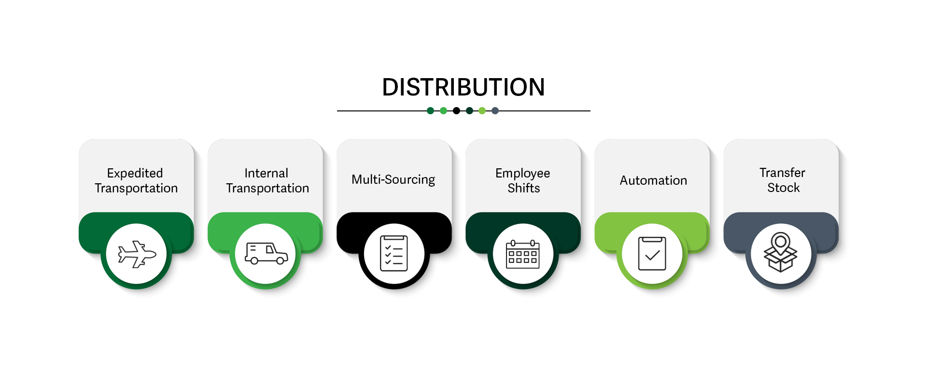

Being prepared requires a thorough understanding of the product's complete journey from the manufacturing facility to its final destination. This knowledge enables quick adaptation to unforeseen distribution and logistics disruptions, such as a trucking accident or a highway pileup.

A fundamental part of a flexible and secure distribution system is not just understanding the logistics but also having backup plans for inevitable shipping delays. These disruptions are beyond anyone's control—whether it's suppliers, distributors, or customers—and no party should bear the financial burden of these unavoidable delays.

Lesson 2: Flexible and Secure Transportation Logistics
Ensuring a flexible and secure manufacturing system goes beyond your facility's walls to include transportation logistics. Having expedited transportation options available enables quick responses to unforeseen demands or delays, giving you the agility to meet customer needs promptly. In addition, an internal transportation system provides greater control over your supply chain, ensuring that essential products reach their destinations even during disruptions. By using a combination of both expedited and internal transportation methods, you can establish a more adaptable and resilient system that effectively addresses logistical challenges.

Using expedited transportation
It's recommended to have expedited transportation options available for on-demand use. This flexibility enables quick movement of products and inventory when there's a need to accelerate deliveries to customers or other locations. By securing daily expedited shipping slots with all carriers, you maintain a consistent flow of outgoing goods. Even if there isn't always product to ship daily, this strategy not only enables regular movement of inventory but also reserves space for additional shipping needs.

While it might seem like a waste of money to pay for something that the company might never need, just remember that health insurance exists. And then remember that there is nothing anyone can do about accidents happening. While it’s wise to have an expedited option, make sure that it makes sense for the company’s needs.

For products that ship frequently, a spot on a plane would work best as it is the quickest way to move products to anywhere in the world. For example, an expensive outdoor store that has a big reputation would want to pay more to ensure that their products get to their customers as soon as possible, especially if their shipment got lost or delayed.

However, larger products that are expected to take an amount of time, such as appliances and furniture, could use trucks and rail for expedited shipping as it will take a few days longer, but be more cost effective due to the weight.

Using internal transportation
Internal transportation requires owning trucks, rail cars, or planes to move the inventory. Having this internal transportation helps ensure that the product gets to its endpoint in the event of transportation delays or sudden changes and gives more control over lead time. Shipping delays are obviously going to happen for various reasons. Maybe the distributor is overhauling their trucks and will be out of service for a few weeks or you need a product quickly and the distributor is not meant to pick up that product until the next month. In either case, there needs to be a way to get that crucial product from one location to another.

Sometimes companies just need a van while others need a full semi-truck. Either way, make sure that there is a sustainable strategy in place to move products around to accommodate the customers even if the monthly inventory is out or delayed.

Lesson 2: Multisourcing, Employee Shifts, and Transfer Stock
In the pursuit of a resilient distribution system that's both flexible and secure, multisourcing, employee management, and inventory transfer are key elements. Multisourcing offers the flexibility to adapt to transportation challenges by using a diverse network of distribution partners and methods. Employee well-being and safety are foundational; thoughtful shift scheduling ensures a rested, efficient team is always available, reducing risks like fatigue, especially during transportation. Finally, regular inventory transfers between distribution centers balance stock levels, ensuring products are ready for dispatch, regardless of location. These strategies combine to create a robust distribution system capable of handling various logistical challenges.

Using multisourcing to create a resilient distribution system

It's recommended to work with multiple distribution channels to reduce lead time and improve operational efficiency, especially when encountering shipping delays or issues.

Multisourcing helps move critical products within multiple distribution partners to ensure that the products arrive during a logistics event, such as a train derailment or a blocked canal. It also helps maintain steady distribution by having different modes of transportation, such as a spot on a boat or a plane in addition to the truck or rail space.

Also take time to identify local distribution networks that can quickly move any items that may have sold out or were lost during shipping.

Modifying employee shifts for distribution safety

Employees are the foundation of any operation, so their well-being should be a priority. Be attentive to the right times to extend or add shifts to evenly distribute the workload among the team. Also, consider providing additional transportation options to ensure that no employees are fatigued while driving.

If needed, create a schedule to add or extend working shifts in a fair and democratic order to spread the work amongst the employees and prevent them from busy season burnout.

Transferring stock
Transfer any out of balance stock between distribution centers on a periodic basis. This helps ensure that there is always an equal amount of product throughout all of the distribution centers and that the product is always ready and available for distribution.

Lesson 3: Using automation to streamline distribution
It is essential to always know where the product is on the supply chain. Visibility in the supply chain refers to the ability to monitor and track the movement and status of goods, inventory, and information throughout the entire process, for example, by creating tags for items. Going digital implies employing technologies, such as ERP software, to facilitate this tracking and management of inventory across the supply chain, ensuring real-time data access and analysis.

Visibility - The ability to view important information throughout a facility or a supply chain no matter where in the facility or supply chain the information is located (ASCM Supply Chain Dictionary).

Increasing automation tracks when the product is moving, how it is getting there, and when it is expected to arrive at its final destination.

Create visibility by physically tagging the inventory and shipping container with either barcodes or active GPS tags and incorporating digital by having a software system that connects into those active GPS tags or barcodes and monitors them throughout the supply chain.

Also automate this process as much as possible to know what to expect and when by configuring the ERP software to automatically run these programs to track inventory.

Use automation as much as possible because it also helps prevent user error when sending out critical and routine orders.

Practice: Building the Distribution System for Resilience

- Why do you want to identify local distribution networks?
  - To move items quickly that have either sold out or need expedited shipping
  - To quickly get products from your warehouse to its endpoint
  - To have extra resources in case you need it for other shipping needs
  - To market the company to other local businesses
Feedback: The best answer is to move items quickly that have either sold out or need expedited shipping. It’s logical to have extra resources when needed and to quickly get products from the warehouse to its endpoint. However, the main purpose of having a local distribution network is to quickly expedite important orders and to restock sold out items.
Learn more about this topic in the Multisourcing, Employee Shifts, and Transfer Stock lesson.

- What is a benefit of using internal transportation methods for your distribution system?

A. It provides less control over lead time.
B. It requires no investment in transportation vehicles.
C. It ensures essential products reach their destinations even during disruptions.
D. It entirely eliminates the risk of shipping delays.

Feedback: The best answer is it ensures essential products reach their destinations even during disruptions. Using internal transportation like owning trucks, rail cars, or planes provides greater control over your supply chain and ensures that essential products reach their destinations even during disruptions.

Learn more about this topic in the Flexible and Secure Transportation Logistics lesson.

- What does automation in a distribution system primarily help with?

A. Automation exclusively assists in the physical tagging of inventory.
B. Automation provides real-time data access and analysis for tracking inventory.
C. Automation replaces the need for human involvement in logistics.
D. Automation eliminates the possibility of logistical disruptions.

Feedback: The best answer is automation provides real-time data access and analysis for tracking inventory. Automation, often through ERP software, provides real-time data access and analysis, which aids in the effective tracking and management of inventory across the supply chain.

Learn more about this topic in the Using Automation to Streamline Distribution lesson.

Section 6: Building the Order Management System for Resilience

Lesson 1: Flexibility and Security in Order Management
The order management system is the backbone for managing inventory, distribution methods, and customer information.

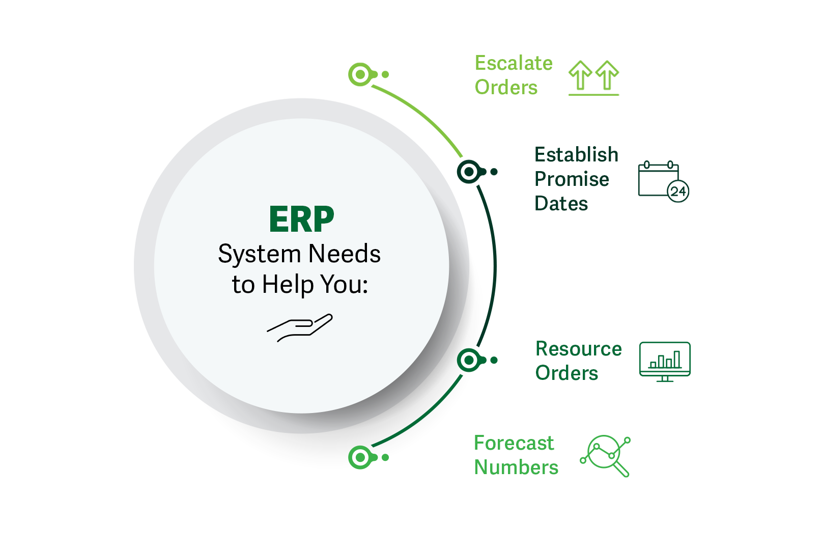

After establishing an ERP software program and setting up security measures to protect the data, configure the system to assist in escalating orders, establishing promise dates, resourcing orders, and forecasting numbers.

Escalating Orders
Most companies need to escalate orders when a customer reaches out about a missing order or a wrong order. The ERP system should escalate regular orders to critical orders and be able to seamlessly escalate orders from start to finish. The ERP should also have the product delivered without delay. Most importantly, leverage the ERP software to monitor the multiple manufacturing options, expedited transportation options, and automated systems to view, escalate, and track the orders.

Establishing Promise Dates
The ERP order management system should provide accurate regular and expedited promise dates. Use this order management ERP software to separate and track the regular shipments as well as the required shorter expedited lead time. This information helps find and communicate reliable delivery dates for the company, the manufacturers, distributors, and the customers.

Resourcing Orders
It's recommended to reroute orders to distribution locations not initially assigned to customers. This strategy offers several advantages, such as logistical optimization, improved inventory management, and faster deliveries, which in turn increase customer satisfaction. It also reduces risks tied to relying on a single distribution center and may lead to cost savings. Additionally, it adds flexibility in meeting market demands and complying with trade regulations.

Lesson 2: Forecasting Numbers
Always forecast the numbers by analyzing data. Analyzing data helps find solutions to most supply chain problems. For instance, if customers are frequently complaining about product quality in a specific location, use the data to narrow down the issue to the specific warehouse that is manufacturing the products and remediate the issue. Or, if a customer is angry about shipping time, use the data to see why the product is taking longer to get to the customer than expected.

Find the issue and adjust accordingly. For example, if customers are having issues with product availability, create a stable supply chain cadence with the manufacturers and distributors and adjust inventory that accounts for appropriate lead time. Forecasting numbers helps prepare for upcoming busy seasons, manufacturing or distribution delays, employee shift changes, inventory fluctuations, and customer behavior.

Accurate forecast numbers helps any business understand what they need to successfully run a supply chain operation. These forecast numbers also help the contractors understand what is expected of them throughout the year. Therefore, it is essential to take as much care as possible when analyzing data and compiling a forecast report.

Always provide purchase forecasts to suppliers reflecting the multisourcing and demand changes to help prepare them for upcoming fluctuations in production and distribution. These forecasts also provide suppliers with short-term and long-term for purchase forecasts to help with their facilities planning.

To compile an accurate forecast, first gather data from over the last three months, a month of data from a busy season, and a month of data from a slow season, if applicable.

After compiling the physical data, start asking some questions, such as:
- How much material did we need?
- How much product was shipped?
- How long did it take to make the product and have it arrive at its final destination?
- How do the slow months compare to the busy months?
- Which products spiked during the busy months?
- Which products are consistent year round?
- Did we escalate any orders? If so, how many and why?
- Are there any customer complaints? If so, is there a theme in those complaints?

Now take those questions and apply them to compiling a forecast. For instance, take how much material was needed during a normal month, during a slow month, and during a busy month to gauge when to alert the manufacturers to a spike in materials and production.

The first few forecast numbers may not be perfect, but keep them around to compare and create more accurate forecasts in the following months.

To create the most accurate forecast as possible, perform the following tasks:
- Analyze the data for the actual versus the forecast numbers.
- Analyze forecast inventory accuracy at full lead time versus shorter lead time.
- Utilize demand management to assess promotional effects, commercial sales, forecasts, and explanations for large forecast misses.

These steps will help create a comprehensive forecast analysis to use when determining if this forecast is more accurate than projecting orders forward to help find ways to increase the forecast accuracy.

When everyone is on the same page, there is less room for error and stress during unexpected events.

Practice: Building the Order Management System for Resilience

- What is the best way to accurately predict a promise date?
  - Track the product in the manufacturing process.
  - Track the regular shipments and the required shorter expedited lead time.
  - Track the product in the distribution center.
  - Track the regular shipments and the longer expedited lead time.
Answer: The best answer is track the regular shipments and the required shorter expedited lead time. While you should know where your product is at all areas of the supply chain, comparing the regular shipments and the shorter expedited lead time is generally the longest it would take as you would not want a longer expedited lead time.

Learn more about this topic in the Flexibility and Security in Order Management lesson.

- How many months of data should be included in a forecast report?
  - One previous month
  - Three previous months
  - Three previous months, one slow month, and one busy month
  - One previous month, one busy month, and one slow month
Feedback: The best answer is three previous months, one slow month, and one busy month. To compile an accurate forecast, first gather data from over the last three months, a month of data from a busy season, and a month of data from a slow season, if applicable. Learn more about this topic in the Forecasting Numbers lesson.

- What is the most important reason for providing a monthly forecasting report to manufacturers and suppliers?
  - To prepare everyone as much as possible for upcoming changes in production
  - To have a better understanding of the data
  - To strengthen the relationship
  - To change production and materials
Feedback: The best answer is to prepare everyone as much as possible for upcoming changes in production. While monthly forecasts are essential for all of the other reasons, to build a secure and resilient supply chain, everyone needs to be on the same page to avoid stress and misunderstandings. Learn more about this topic in the Forecasting Numbers lesson.

Section 7: Building Materials Management System for Resilience

Lesson 1: Flexible and Secure Components in Materials Management
To build a resilient system, concentrate on six essential materials management components: data, triplet systems, demand sensing, research reasoning, automation, and infrastructure. These components collectively offer insights into changing data patterns, material availability, customer demand, and order errors. The goal is to keep enough material and enough stock, along with a knowledgeable network to help ensure that the company always has what it needs and a way to get it there in time.

Select the buttons in the label graphic below to learn more.

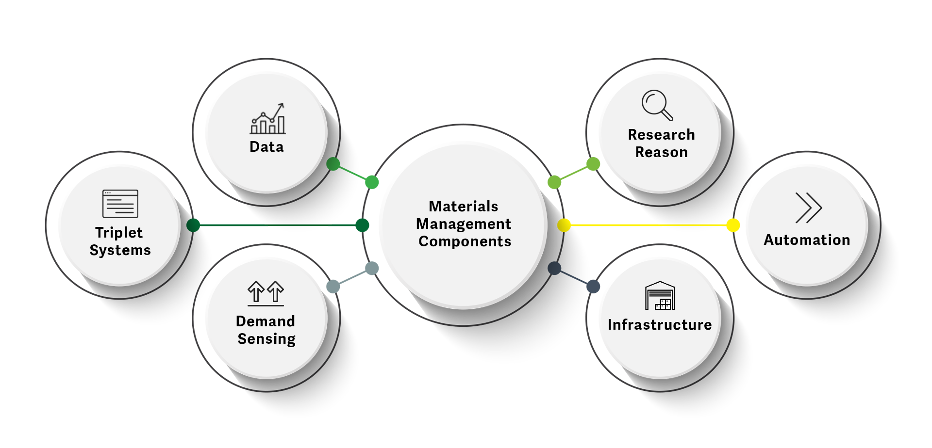

Analyzing materials management data
Creating a digital twin is aimed at backing up customer and business data, as well as aiding in the establishment of a manufacturing and material requirements plan. Use this data to accurately predict consistent orders, peak seasons, new order estimates, and current manufacturing concerns found through customer reviews. Always make sure that the company, distributors, and manufacturers have the right amount of materials to create the products through the normal and busy season; enough extra materials to compensate for large, unpredictable orders; a way to gauge how often new orders come in and for which products; and a way to find and fix any customer issues, including manufacturing or distribution issues.

Tripleting systems
It can be a good strategy to triplet the current management systems with one strong expedited sourcing, routing, and transportation system. This tactic helps store expedited sourcing rules, lead times, and transportation with a strong expedited carrier while maintaining normal operations with standard manufacturers and distributors.

This strategy is particularly suited for critical materials, for example, if a party supplier needs to manufacture and distribute 1,000 units in an expedited way, they have multiple systems in place to plan for normal operations and expedited operations.

It is generally best to use the expedited way only when needed or when building contracted capacity on expedited carriers. Always try to completely fill up the contracted capacity on an expedited 747 plane before flying out.

Using demand sensing to prepare for large orders
Demand sensing helps prepare for large, out-of-the-ordinary orders by configuring the ERP system to trigger an alert when a large and unexpected order comes into the system. For instance, a party supplier would configure their system to trigger any time a corporate office submits a bulk order for birthday hats. The party supplier then checks this alert in the system and sends those updates to their suppliers, manufacturers, and distributors.

Find out how to configure an alert for orders in excess of the demand plan for the specific ERP system in use so that it alerts the system any time there is a large order that is not previously on the docket. For instance, that same party supplies business already expects an uptick in orders around large holidays, such as St. Patrick’s Day, Halloween, and Christmas. However, they may not expect a 600 birthday hat order in November. The demand sensing alert helps them prepare for the order without disrupting normal operations.

Using research reasons to detect misunderstandings
Most ERP systems have alerts that detect possible order misunderstandings such as unit of measure (inches to centimeters) or weight (pounds to kilograms). Always configure the ERP system to detect possible misunderstandings, if possible, and have the sales department check with customers for large commercial orders to validate the order needs.

Using automation to manage materials
Use the available automation features in the ERP system to update orders, customer information, product information, and scheduling on a consistent basis. However, always teach the employees how to start and stop these automated processes so that they can control them.

Infrastructure
All companies should have both cloud and on-premise infrastructure for critical processes. This action helps ensure that the processes are always running in the cloud and on the internal management systems. It is generally best to have established on-premise infrastructure for critical processes first, and then have those same processes replicated in the cloud for extra help and security.

Practice: Building the Materials Management System for Resilience

- In the context of materials management, which example best illustrates a misunderstanding that research reasoning can detect in an ERP system?

A. Confusing production date with promise date
B. Mixing up production date with shipping date
C. Misinterpreting shipping address numbers
D. Converting pounds to kilograms incorrectly

Feedback: The best answer is converting pounds to kilograms incorrectly. Research reasoning in ERP systems is designed to detect possible misunderstandings such as unit of measure or weight. In this context, it can catch errors like incorrect conversions between pounds and kilograms. This feature is particularly useful for industries like furniture or appliance manufacturing, which often deal with specific weight and product measurements.

Learn more about this topic in the Flexible and Secure Components in Materials Management lesson.

- Which statement accurately explains the purpose of triplet systems in materials management?

A. To store expedited sourcing rules and lead times
B. To convert units of measure and weight
C. To back up customer and business data
D. To automatically update customer and product information

Answer: The best answer is to store expedited sourcing rules and lead times. The purpose of triplet systems is to store expedited sourcing rules, lead times, and transportation with a strong expedited carrier while maintaining normal operations with standard manufacturers and distributors.

Learn more about this topic in the Flexible and Secure Components in Materials Management lesson.

Summary and Review
A robust and resilient supply chain comprises four interconnected systems: manufacturing, distribution, order management, and materials management. These systems collectively form the backbone of the supply and demand cycle by creating products, facilitating their movement, managing orders, and overseeing data systems. To ensure a strong supply chain, each of these systems must be both secure and flexible.

A flexible manufacturing system guarantees product availability by having multiple materials suppliers and production warehouses producing the same items. This approach enables continuous production even during unexpected shortages caused by shipping delays, lack of supply, or unforeseen events, such as electrical fires or plant explosions.

A secure distribution system ensures timely delivery by relying on internal transportation as well as multiple distributors available to move the products to another location. This strategy moves products even when they are not scheduled for delivery within the primary distribution network.

A flexible and secure order management promises effective order placement, escalation, and expedited shipping requests. A comprehensive order management system seamlessly moves orders throughout the supply chain while providing comprehensive data for analysis.

A flexible and secure materials management system establishes clear communication among the company, its suppliers, manufacturers, and customers. A stable materials management system alerts the system to upcoming changes in data, materials, customer demand, and order errors.

When establishing a secure and resilient supply chain, businesses will likely choose between one of the two primary strategies: horizontal or vertical. A horizontal strategy involves signing contracts with external manufacturers and distributors, making it practical for companies lacking raw materials, space, or production capabilities. Common businesses, such as large grocery chains and department stores, rely on horizontal strategies since they source products from multiple suppliers. In contrast, a vertical strategy means owning the entire production and distribution process, which is ideal for industries with direct access to raw materials, such as oil refineries and mining companies. A blend of these strategies, seen in department stores, combines in-house production for specific brands with external manufacturers for other products.

Regardless of the approach, the chosen strategy shapes the supply chain's resilience, emphasizing the importance of building adaptable systems capable of weathering unexpected challenges.

EOM Performance Check

- What is a key benefit of having a flexible manufacturing system in a supply chain?
- Decreased lead time for product delivery
- Increased dependence on a single supplier
- Limited production capabilities during unexpected events
- Reduced need for production warehouses
Feedback: The best answer is decreased lead time for product delivery. A flexible manufacturing system, achieved through multiple materials suppliers and production warehouses, ensures that products can be manufactured even during unexpected events, reducing lead time for product delivery.
Learn more about this topic in the Defining strong supply chain systems lesson.

- How can a company ensure a secure distribution system in its supply chain?
- Relying solely on a single transportation method
- Multisourcing different types of transportation and routes
- Ignoring weather-related disruptions in transportation
- Renting transportation on an as-needed basis
Feedback: The best answer is multisourcing different types of transportation and routes. A secure distribution system is ensured by multi-sourcing different types of transportation and routes, allowing products to move regardless of outside events such as inclement weather or transportation breakdowns.
Learn more about this topic in the Defining strong supply chain systems lesson.

3. Which strategy often leads to better control and reduced dependency on external suppliers?
- Horizontal
- Vertical
- Hybrid
- Outsourced

The best answer is vertical. A vertical strategy enhances control by integrating different levels of the supply chain, which also reduces dependency on external suppliers, promoting efficiency and security.

Learn more about this topic by visiting the How Strategy Contributes to a Flexible and Secure Supply Chain lesson.

- What is the primary consideration in choosing a supply chain strategy?
- Reducing costs and streamlining operations
- Owning the entire production process
- Having access to unlimited raw materials
- Building a resilient and adaptable system
Feedback: The best answer is building a resilient and adaptable system. The choice of a supply chain strategy should focus on building a resilient, adaptable system that can withstand challenges and disruptions, rather than just reducing costs or streamlining operations.
Learn more about this topic in the How strategy contributes to a flexible and secure supply chain lesson.

- What is one of the essential steps in creating a secure supply chain?
- Negotiating contracts with suppliers and manufacturers
- Conducting regular disaster drills at all physical locations
- Storing hazardous materials near busy areas to maximize accessibility
- Relying solely on insurance to protect against supply chain risk
Feedback: The best answer is conducting regular disaster drills at all physical locations. Regular disaster drills are crucial to protect your employees, warehouse, and inventory from various potential disasters and outside events, making them a vital step in creating a secure supply chain.
Learn more about this topic in the Using prevention to create a secure supply chain lesson.

- Why is creating a digital twin important for protecting data in a supply chain?
- It allows for real-time data analysis.
- It prevents data from being collected.
- It provides an online copy of data for recovery.
- It speeds up data transmission.
Feedback: The best answer is it provides an online copy of data for recovery. Creating a digital twin is crucial for data protection as it provides a copy of data, stored in a secondary server, safeguarding it from hackers and viruses, and enabling data recovery in case of an incident.
Learn more about this topic in the Protecting Data lesson.

- What should be included in supply chain contracts to ensure clear expectations?
- Company address and contact information
- Lead time and order frequency
- Environmental standards and safety measures
- Marketing and advertising strategies
Feedback: The best answer is lead time and order frequency. Supply chain contracts should define order cadence, order frequency, lead time, and other critical details to maintain clear expectations between parties involved in the supply chain.
Learn more about this topic in the Writing contracts for security, reliability, and accountability lesson.

- What type of product is typically best suited for multisourcing to ensure availability during disruptions?
- Products that are manufactured in bulk
- Products with high-quality materials
- Products that are configured to order
- Products that are consistently in demand
Feedback: The best answer is products that are consistently in demand. Multisourcing is typically best suited for products that are consistently in demand to ensure their availability during disruptions. These products should be manufactured at multiple plants to maintain a steady supply.
Learn more about this topic in the Multisourcing, Employee Shifts, and Automation lesson.

- Why is it important to schedule daily expedited transportation even if there might not be products to transport every day?
- To maintain a consistent shipping schedule
- To minimize transportation costs
- To prepare for unexpected shipping emergencies
- To avoid overloading carriers with daily shipments
Feedback: The best answer is to prepare for unexpected shipping emergencies. Scheduling daily expedited transportation, even if there might not be products to transport every day, helps prepare for unexpected shipping emergencies. Having this option ensures that products can be moved quickly in case of urgent situations, maintaining business continuity, and customer satisfaction.
Learn more about this topic in the Flexible and Secure Transportation Logistics lesson.

- What is the primary purpose of demand sensing in materials management?
- To predict future manufacturing concerns
- To prepare for large, unexpected orders
- To automate routine order processing
- To reduce manufacturing costs
Feedback: The best answer is to prepare for large, unexpected orders. Demand sensing in materials management is used to prepare for large, unexpected orders by alerting the organization to out-of-the-ordinary demands. It helps businesses respond promptly to sudden spikes in orders and ensures suppliers and distributors are prepared, preventing disruptions in normal operations.
Learn more about this topic in the Flexible and Secure Components in Materials Management lesson.

